SPIKE IT UP: PADDLE STYLE

STUDENT TARGETS
- Skill: I will demonstrate a variety of striking and Roundnet skills required to score points for my team.
- Cognitive: I will identify ways my team can work together cooperatively during the game.
- Fitness: I will stay actively engaged during this activity.
- Personal & Social Responsibility: I will demonstrate integrity and proper etiquette by respecting others and following the rules of the game.

EQUIPMENT & SET-UP | 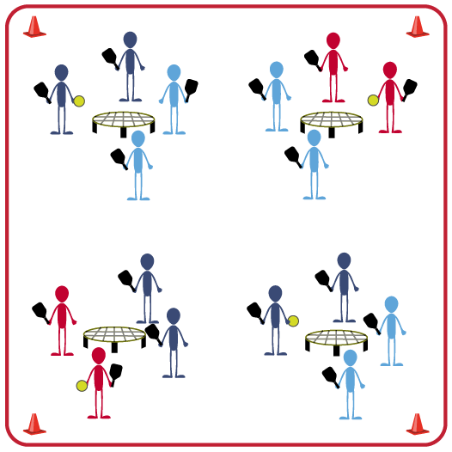
Equipment:
- 1 Spikeball® net (or hoop) per group of 4 students
- 1 Spikeball® SpikePaddle set per group of 4 students
- Use hoops and foam balls if you do not have enough Spikeball® sets for entire class

Set-Up:
- Scatter nets (or hoops) in the activity area, allowing space for player movement.
- Place 4 Spikeball® SpikePaddles and a ball at each net.
- Pair students and send 2 pairs (4 players) to each net.
ACTIVITY PROCEDURES
- This activity is called Spike it Up: Paddle Style. The object of the activity is to score more points than the other team. This game is played just like Roundnet, but you strike the ball with your paddle instead of your hand.
- On the start signal, play Rock, Paper, Scissors to determine which team will serve first to begin the game. Teams have a maximum of 3 hits (2 passes and 1 spike) to send the ball down to the net for a change of possession.
- We will play 5-minute games. At the end of each game, the winning team will stay at their net and the other team will rotate and find a new team to challenge. All paddles and balls stay at the net when you rotate.
- The game will continue until one team gets to 21 points or you hear the stop signal.

DEBRIEF QUESTIONS
- DOK 1: What is integrity?
- DOK 2: Why is integrity important in physical activity or competitive settings?
- DOK 3: How is integrity related to the enjoyment of everyone playing a game of Roundnet?

PRIORITY OUTCOMES
Etiquette:
- Grades 3-5: Recognizes the role of rules and etiquette in physical activity with peers.
- Grades 6-8: Exhibits etiquette and adherence to rules in a variety of physical activities.
- Grades 9-12: Exhibits proper etiquette, respect for others, and teamwork while engaging in physical activity and/or social dance.

