BUCKET GOLF

STUDENT TARGETS
- Skill: I will focus on accuracy and distance when chipping a golf ball.
- Cognitive: I will identify ways to chip for accuracy and distance.
- Fitness: I will stay actively engaged throughout the activity.
- Personal & Social Responsibility: I will use positive self-talk and encouraging language with my partner during Bucket Golf challenges.

EQUIPMENT & SET-UP | 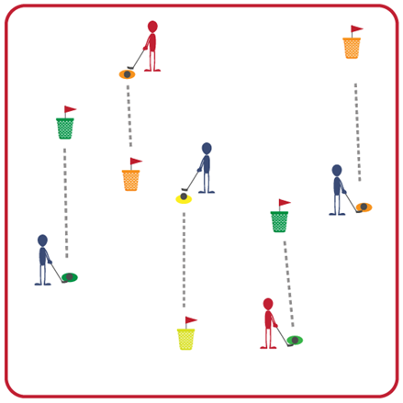
Equipment:
- Bucket Golf 6-Hole or 9-Hole Set
- 1 club and one plastic golf ball per 2 students

Set-Up:
- Set up the Bucket Golf course so that each hole is 10-20 feet in distance from the tee box to the bucket. Buckets are pinned to the ground using the flag sticks.
- Design the course so the end of each hole is where the next hole begins.
- Create groups of 2 students; each pair begins by a tee box with a club and a ball.
ACTIVITY PROCEDURES
- This activity is called Bucket Golf. The object is to keep your score as low as possible. This occurs by chipping the ball into the bucket or needing as few hits as possible to get to the bucket.
- Every hole in Bucket Golf is a par 3, which means you have 3 shots to get to the bucket to get a par for that hole. Hitting any part of the bucket will end the hole, but chipping into the bucket subtracts one stroke off your score for that hole. For example, if you hit the outside of the bucket on your third shot your score would be a 3 for that hole. If you hit the ball into the bucket on your third shot, your score would be a 2 for that hole.
- On the start signal, one partner will attempt to chip the ball into the bucket. Once they have hit the ball into the bucket or hit any part of the bucket, you will determine their score and switch roles. Once both of you have completed that hole, you will move on to the next one. All of the tee boxes have numbers to help guide you from one hole to the next as you complete the course.

DEBRIEF QUESTIONS
- DOK 1: What are some strategies that can help with accuracy in golf?
- DOK 1: What are some strategies that can help with hitting the ball the correct distance?
- DOK 2: Sometimes golf can be a challenging activity. What are some examples of positive self-talk or encouraging language that you experienced or observed during the activity?

PRIORITY OUTCOMES
Social Interaction:
- Grades 3-5: Describes the positive social interactions that come when engaged with others in physical activity.
- Grades 6-8: Demonstrates respect for self and others in activities and games by following the rules, encouraging others, and playing within the spirit of the game or activity.
- Grades 9-12: Demonstrates the importance of social interaction by helping and encouraging others, avoiding trash talk, and providing support to classmates.

