DISC GOLF

STUDENT TARGETS
- Skill: I will complete the disc golf course in the fewest strokes possible.
- Cognitive: I will identify strategies to help with distance and accuracy when throwing.
- Fitness: I will stay actively engaged throughout the activity.
- Personal & Social Responsibility: I will identify ways to work safely and independently during physical activities both in and outside of school.

EQUIPMENT & SET-UP | 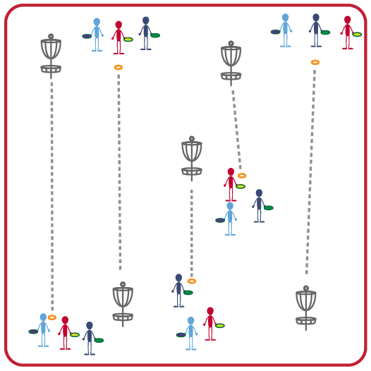
Equipment:
- 9-Hole Disc Golf Target Set (another option is slot cones and hoops)
- Foam Flying Discs
- Low profile cones to identify tee area
Set-Up:
- Set up the Disc Golf course so that each hole is 50-75 feet in distance from the tee area to the target.
- Design the course so the end of each hole is where the next hole begins, but with enough space between for safety.
- Create groups of 2-3 students; each group begins by a tee area. Each student begins with a disc. Use different color disc for each group member if possible.
ACTIVITY PROCEDURES
- This activity is called Disc Golf. The object is to play each hole with the fewest throws possible to keep your score low. This game is played like traditional golf, but with discs instead of golf balls and clubs.
- Every hole on our disc golf course will be a par 3, which means you have 3 throws to get a par for that hole. Throwing the disc through the target hoop will complete the hole.
- On the start signal, each partner will begin with a tee throw (with one person throwing at a time). You will leave the disc on the ground where it landed until all group members have made their tee throw. You will then continue alternating to throw the disc towards/through the target. Once you have completed the hole, you will determine your score (total number of throws to get the disc through the hoop target). Once each of you have completed that hole, you will move on to the next one. The hoop targets have numbers to help guide you from one hole to the next as you complete the course.

DEBRIEF QUESTIONS
- DOK 1: What are some strategies that can help with accuracy in disc golf?
- DOK 1: What are some strategies that can help with throwing the disc the correct distance?
- DOK 2: What are things you need to do to play disc golf safely both in and outside of physical education class?

PRIORITY OUTCOMES
Personal Responsibility and Safety:
- Grades 3-5: Works independently and safely in physical activity settings.
- Grades 6-8: Uses effective self-monitoring skills to incorporate opportunities for physical activity in and outside of school.
- Grades 9-12: Applies best practices for participating safely in physical activity, exercise, and dance.

