1v1 FLAG TAG

STUDENT TARGETS
- Skill: I will analyze offensive and defensive movements and make adjustments to create a strategic advantage.
- Cognitive: I will identify the different strategies needed when on offense vs. defense.
- Fitness: I will stay actively engaged during the activity.
- Personal & Social Responsibility: I will communicate with my partner using positive language.

EQUIPMENT & SET-UP | 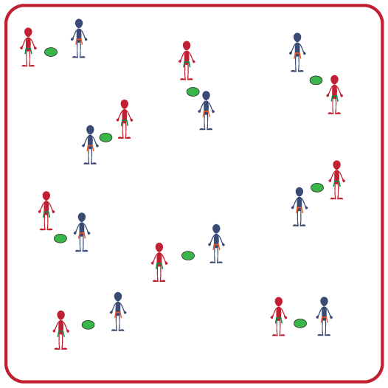
Equipment:
- 1 spot marker per group of 2 students
- 1 flag belt per student

Set-Up:
- Scatter spot markers in the activity area with enough space to safely move around each spot.
- Create pairs of 2 students. All students will be wearing a flag belt.
- Each pair begins by a spot marker.
ACTIVITY PROCEDURES
- This activity is called 1v1 Flag Tag. The object of the game is for the person on offense to pull the flag of the person on defense.
- 1 point is earned each time you are able to successfully pull the flag belt of the defender.
- Decide which person will start on offense by playing Rock, Paper, Scissors.
- You will begin facing your partner with the spot marker in between you. The person on offense will begin side sliding around the spot marker to try and pull the defender’s flag belt. The defender will move away to avoid having their flag pulled.
- Both players must stay within 3 feet of the spot marker, or it is an automatic flag pull.
- If a flag belt is pulled, you will change roles (offense to defense) and play again.
- Once you hear the stop signal, the player with the most points will stay and their partner will find a new student to challenge before we play again. You will determine who starts on offense by playing Rock, Paper, Scissors each time you have a new partner.

GRADE LEVEL PROGRESSION
- Grade 6: Play as described above.
- Grades 7 & 8: Have the student on defense hold a football to practice moving with the ball.

TEACHING CUES
- Cue 1: Communicate with your teammates using positive language.
- Cue 2: Pull down on the flag when trying to pull the flag belt from your partner.
- Cue 3: Anticipate the movements of your partner when on offense.
- Cue 4: Remember to show respect and hand the flag back to your partner after you pull it.
1v1 FLAG TAG (continued…)

UNIVERSAL DESIGN FOR LEARNING
- UDL 1: Allow students to use objects of different sizes, colors, weights, and textures.
- UDL 2: Decrease the size of the activity space if needed.
- UDL 3: Use peer partners as needed.
- UDL 4: Provide verbal cues and visual demonstrations for each challenge.

ACADEMIC LANGUAGE
Offense, Defense, Communication, Respect

PRIORITY OUTCOMES
Movement Concepts:
- Analyzes movement and activity situations and makes adjustments with a specific purpose or to create a strategic advantage.

DEBRIEF QUESTIONS
- DOK 1: How would you define a strategy?
- DOK 2: What was a strategy you used or saw your partner use on offense? What was a strategy you used or saw your partner use on defense?
- DOK 3: If the strategy was not successful, what changes did you or your partner make to adjust? What was the outcome of those changes?

