RHYTHM & ROPES

STUDENT TARGETS
- Skill: I will complete a variety of jump rope skills and challenges.
- Cognitive: I will identify why rhythm is important when jumping rope.
- Fitness: I will stay actively engaged in all the jump rope challenges.
- Personal & Social Responsibility: I will discuss opportunities to address challenging jump rope skills in a positive way.

EQUIPMENT & SET-UP | 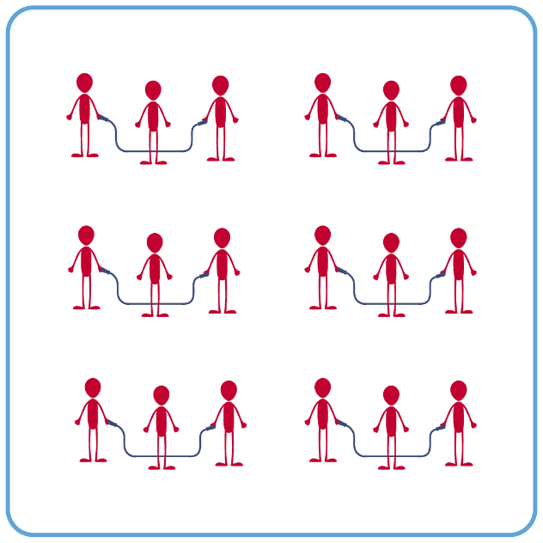
Equipment:
- 1 single jump rope per student (ensure that ropes of various lengths are available for students to select)
- 1 long rope per group of 3-4 students
- Rope Selection Rules Poster
- Technology for demonstrations of jump rope skills/challenges (if available).
- Skill videos provided here by Learnin’ The Ropes (click “Join” and Log in to access)

Set-Up:
- Create groups of 3-4 students. Each group will begin with a long rope.
- Each group will spread out in general space, a safe distance from their classmates.
ACTIVITY PROCEDURES
- We are going to try some single rope and some long rope skills today! We will continue to build our jump rope skills as we move through a variety of different challenges.
- We are going to start with some long rope challenges. You will work with a team and rotate through being the jumper and the rope turner.
  - Entrance
  - Exit
  - Rapid Fire
- It is important that everyone has a single rope that is the proper length for them. The Rope Selection Rules poster that is near the jump ropes will help you make the correct choice.
- Now that everyone has a single rope, we are going to try a variety of individual jump rope challenges.
  - X-Motion
  - Side Cross
  - Leg Over
  - Combination 3

GRADE LEVEL PROGRESSION
- Grade 6: Participate in jump rope skills described above.
- Grades 7 & 8: Challenge students to try and complete 30 seconds with a single rope, while performing any of the single rope skills they have learned so far.

TEACHING CUES
- Cue 1: Ensure you are safely spaced away from classmates before jumping.
- Cue 2: Keep a growth mindset, and if you make a mistake just reset and try again!
RHYTHM & ROPES (continued…)

UNIVERSAL DESIGN ADAPTATIONS
- UDL 1: Allow students to use ropes in a variety of weights, colors, and lengths.
- UDL 2: Allow students to jump an “invisible” rope (e.g., line on floor).
- UDL 3: Use peer partners as needed.
- UDL 4: Provide verbal cues and visual demonstrations for each challenge.

ACADEMIC LANGUAGE
Challenge, Long Rope, Entrance, Exit, Rhythm

PRIORITY OUTCOMES
Personal Challenge:
- (Grade 6) Recognizes individual challenges and copes in a positive way, such as extending effort, asking for help/feedback, and/or modifying the tasks.
- (Grade 7) Generates positive strategies such as offering suggestions/assistance, leading/following others, and/or providing possible solutions when faced with a group challenge.
- (Grade 8) Develops a plan of action and makes appropriate decisions based on that plan when faced with a challenge.

DEBRIEF QUESTIONS
- DOK 1: What does the word rhythm mean?
- DOK 2: Why is rhythm important when jumping rope?
- DOK 3: What will happen if the long rope turners and the jumpers are not in the same rhythm? Why?

