CATCH AND SCORE

STUDENT TARGETS
- Skill: I will apply movement concepts to safely chase or flee from my partner.
- Cognitive: I will identify ways to safely move when chasing or fleeing.
- Fitness: I will stay actively engaged during the activity.
- Personal & Social Responsibility: I will demonstrate leadership skills and communicate in a respectful way with my teammates.
EQUIPMENT & SET-UP | 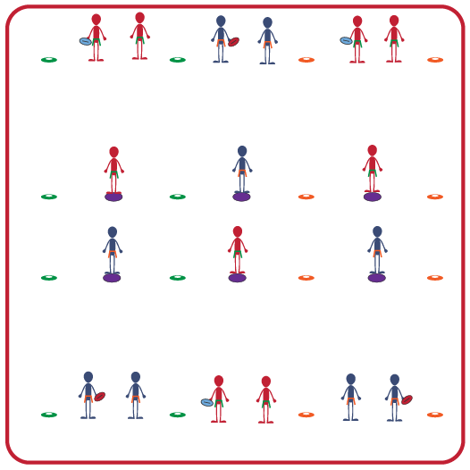
Equipment:
- 1 football (or any tossable object) per 3 students
- 1 flag belt per student
- Low profile cones for endlines; 4 boundary cones per 3 students
- 1 spot marker per 3 students
Set-Up:
- Create groups of 3 students. All students will be wearing a flag belt.
- Set up endlines with low profile cones on each side of the activity space. Place 4 boundary cones and a spot marker about 30 feet (10 yards) away to delineate where receivers begin.
- Each group will begin with 2 students standing on the endline (Quarterback and the Defender), and 1 student facing them on a spot marker (Receiver). Quarterback begins with a football (or other tossable object).
ACTIVITY PROCEDURES
- This activity is called Catch and Score. The object of the game is for the receiver to make it across the end line without getting their flag pulled.
- You will begin with the Quarterback and Defender standing on the end line. The Quarterback will have a football. The Receiver will begin by a spot marker facing their teammates.
- On the start signal, the Quarterback will throw the ball to the receiver. Once the ball is caught (or picked up if not caught), the receiver will try to score by getting across the endline without getting their flag pulled, going out of bounds, or falling to the ground. Both the Quarterback and the Defender will attempt to pull the Receiver’s flag, but cannot move from the endline until the Receiver has the ball and is moving towards them.
- 1 point is earned each time the person with the ball can successfully make it across the endline without getting their flag pulled.
- You will continue to rotate positions after each attempt to pass and score. Quarterback moves to Receiver, the Defender moves to Quarterback, and the Receiver moves to Defender.
GRADE LEVEL PROGRESSION
- Grade 6: Play without a Defender, and only the Quarterback can pull the flag of the Receiver.
- Grades 7 & 8: Play as described above. Shorten or lengthen the field as needed.
TEACHING CUES
- Cue 1: Communicate with your teammates using positive language.
- Cue 2: Pull down on the flag when trying to pull the flag belt from your partner.
- Cue 3: Be aware of your surroundings and keep your eyes up in order to move safely through the activity space.
- Cue 4: Remember to show respect and hand the flag back to your partner after you pull it.
CATCH AND SCORE (continued…)

UNIVERSAL DESIGN FOR LEARNING
- UDL 1: Allow students to use objects of different sizes, colors, weights, and textures.
- UDL 2: Decrease or increase the size of the activity space if needed.
- UDL 3: Use peer partners as needed.
- UDL 4: Provide verbal cues and visual demonstrations for each challenge.

ACADEMIC LANGUAGE
Quarterback, Defender, Receiver, Leadership, Communication

PRIORITY OUTCOMES
Locomotor Skills:
- Combines locomotor skills with movement concepts in dance, fitness, and sport environments.

Social Interaction:
- Demonstrates the importance of social interaction by helping and encouraging others, avoiding trash talk, and providing support to classmates.

DEBRIEF QUESTIONS
- DOK 1: How would you describe what leadership is?
- DOK 2: Did you or any of your teammates demonstrate leadership during the activity? Give an example and describe how it was leadership.
- DOK 3: If a group or team isn’t finding success, how could one or more teammates stepping up as a leader potentially lead to the team being successful? What would communication from a leader sound like?

