JUMP JAMS

STUDENT TARGETS
- Skill: I will complete a variety of jump rope skills and challenges.
- Cognitive: I will identify the relationship between health-related fitness components and my personal health.
- Fitness: I will stay actively engaged in all the jump rope challenges.
- Personal & Social Responsibility: I will discuss opportunities for physical activity that can enrich physical, mental, and emotional health.

EQUIPMENT & SET-UP | 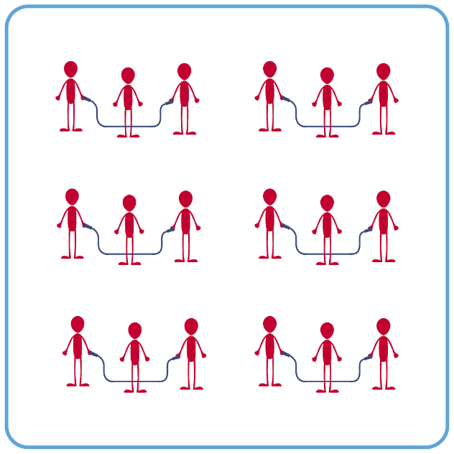
Equipment:
- 1 single jump rope per student (ensure that ropes of various lengths are available for students to select)
- 2 long ropes per group of 3-4 students
- Rope Selection Rules Poster
- Technology for demonstrations of jump rope skills/challenges (if available).
- Skill videos provided here by Learnin’ The Ropes (click “Join” and Log in to access)

Set-Up:
- Create groups of 3-4 students. Each group will begin with a long rope.
- Each group will spread out in general space, a safe distance from their classmates.
ACTIVITY PROCEDURES
- We are going to try some single rope and some long rope skills today! We will continue to build our jump rope skills as we move through a variety of different challenges.
- We are going to start with some long rope challenges. You will work with a team and rotate through being the jumper and the rope turner.
  - Touch the Ground
  - Mini Rainbow
  - Double Dutch Turning (no jumpers yet)
- It is important that everyone has a single rope that is the proper length for them. The Rope Selection Rules poster that is near the jump ropes will help you make the correct choice.
- Now that everyone has a single rope, we are going to try a variety of individual jump rope challenges.
  - Speed Step
  - Backward Criss Cross
  - Double Under Criss Cross
  - Combination 4

GRADE LEVEL PROGRESSION
- Grade 6: Participate in jump rope skills described above.
- Grades 7 & 8: Students will work with partners. Two students turn a long rope, while 2 students partner jump inside of the long rope.

TEACHING CUES
- Cue 1: Ensure you are safely spaced away from classmates before jumping.
- Cue 2: Keep a growth mindset, and if you make a mistake just reset and try again!
JUMP JAMS (continued…)

UNIVERSAL DESIGN ADAPTATIONS
- UDL 1: Allow students to use ropes in a variety of weights, colors, and lengths.
- UDL 2: Allow students to jump an “invisible” rope (e.g., line on floor).
- UDL 3: Use peer partners as needed.
- UDL 4: Provide verbal cues and visual demonstrations for each challenge.

ACADEMIC LANGUAGE
Double Dutch, Personal Health, Health-related Fitness

PRIORITY OUTCOMES
Personal Health:
- (Grade 6) Describes how physical activity positively impacts the body to promote good health.
- (Grade 7) Identifies and explains the relationship between the 5 components of health-related fitness and disease prevention.
- (Grade 8) Seeks out and identifies physical activity options to enrich physical, emotional, and mental health for self and others.

DEBRIEF QUESTIONS
- DOK 1: What is personal health?
- DOK 2: How could the components of health-related fitness impact your personal health?
- DOK 3: Discuss opportunities for physical activity that can enrich physical, mental, and emotional health. How could you find opportunities for a variety of physical activities in your community?

