TOUCHDOWN RUN

STUDENT TARGETS
- Skill: I will apply movement concepts to safely chase or flee from my partner.
- Cognitive: I will identify ways to safely move when chasing or fleeing.
- Fitness: I will stay actively engaged during the activity.
- Personal & Social Responsibility: I will demonstrate ways to support and encourage my teammates.
EQUIPMENT & SET-UP | 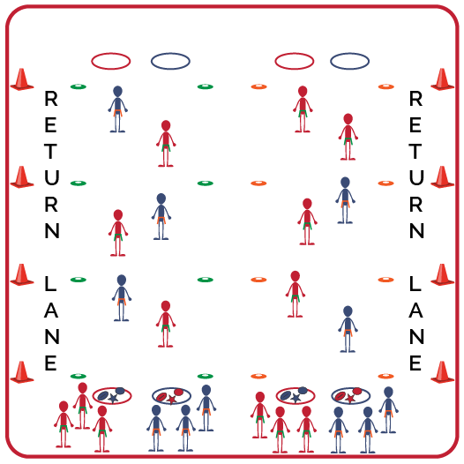
Equipment:
- Variety of objects (e.g., bean bag, foam ball, football, etc.)
- 1 flag belt per student
- Low-profile cones to mark “Tag Zones”
- Medium sized cones for returning lanes
- 2 hoops per team of 3
Set-Up:
- Create teams of 3 students. All students will be wearing a flag belt. 2 of the teams will begin in middle as defenders (total of 6 students). 2 defenders will be in each tagging zone: 1st zone are Linemen; 2nd zone are Linebackers; 3rd zone are Safeties.
- Set up starting line with a hoop for each team of 3. Each hoop should have several different items in it. Teams line up behind their hoop.
- On opposite end, place a matching empty hoop for each team.
- Use medium sized cones to delineate the return lanes and low-profile cones to delineate the 3 tagging zones on both sides of activity space.
ACTIVITY PROCEDURES
- This activity is called Touchdown Run. The object is to earn points by moving the items in your team’s hoop to the other side by making it through all 3 tag zones without getting your flag pulled.
- Each team will line up behind a hoop. On the start signal, one person from each team will attempt to make a “Touchdown Run” across all 3 tag zones to the other side of the activity area carrying one of the items from your hoop. Only one person from each team can attempt to go through at a time.
- Defenders cannot leave their assigned zone. Linemen must stay in zone 1, Linebackers must stay in zone 2, and Safeties must stay in zone 3.
- If your flag is pulled in any tag zone, you will retrieve your belt and move to the outside return lanes to go back to your team’s hoop. There are safety zones between each tag zone as you move through.
- If you make it through without your flag being pulled, place the item you were carrying in your team’s hoop on the other side and use the return lanes to come back. (Teacher Note: assign points for each item moved successfully: football = 7 points; foam ball = 5 points; bean bag = 3 points, etc.)
- You will continue to send one teammate at a time through the tag zones to make as many Touchdown Runs as you can. The 2 teams with the most items moved will be our defenders for the next round.
GRADE LEVEL PROGRESSION
- Grade 6: Play as described above.
- Grades 7 & 8: Students can enter immediately if a teammate is tagged/makes it all the way across.
TEACHING CUES
- Cue 1: Communicate with your teammates using positive language.
- Cue 2: Be aware of your surroundings and keep your eyes up in order to move safely through the activity space.
TOUCHDOWN RUN (continued…)

UNIVERSAL DESIGN FOR LEARNING
- UDL 1: Allow students to use objects of different sizes, colors, weights, and textures.
- UDL 2: Decrease or increase the size of the activity space if needed.
- UDL 3: Use peer partners as needed.
- UDL 4: Provide verbal cues and visual demonstrations for each challenge.

ACADEMIC LANGUAGE
End Zone, Agility, Support, Encourage

PRIORITY OUTCOMES
Locomotor Skills:
- Combines locomotor skills with movement concepts in dance, fitness, and sport environments.

Social Interaction:
- Demonstrates the importance of social interaction by helping and encouraging others, avoiding trash talk, and providing support to classmates.

DEBRIEF QUESTIONS
- DOK 1: How would you describe encouraging a teammate?
- DOK 2: If one of your classmates was not feeling successful during the activity, what are some ways you could encourage or support them?
- DOK 3: How does encouraging your teammates impact your team as a whole?

