CREATIVE COMBOS

STUDENT TARGETS
- Skill: I will create and perform a jump rope routine.
- Cognitive: I will include 4 different single rope skills to create a 32-count jump rope routine that flows from one skill into the next.
- Fitness: I will stay actively engaged in all the jump rope challenges.
- Personal & Social Responsibility: I will discuss ways to apply rules and etiquette while creating and performing jump rope routines.

EQUIPMENT & SET-UP | 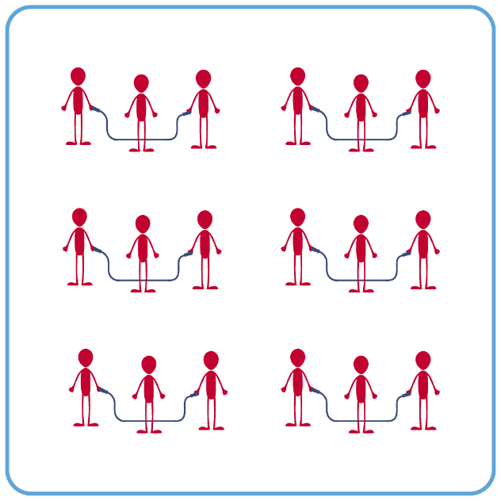
Equipment:
- 1 single jump rope per student (ensure that ropes of various lengths are available for students to select)
- 2 long ropes per 3-4 students
- Rope Selection Rules Poster
- Technology for demonstrations of jump rope skills/challenges (if available).
- Skill videos provided here by Learnin’ The Ropes (click “Join” and Log in to access)
Set-Up:
- Create groups of 3-4 students. Each student begins with a single rope.
- Each group will spread out in general space, a safe distance from their classmates.

ACTIVITY PROCEDURES
- We are going to finish up our Jump Rope unit with you creating combination routines.
- You will begin working as a group to create a 32-count jump rope routine. Your group needs to choose and include 4 different single rope skills in the routine, that are 8-counts each. They can be ones we have learned or new skills that you have created yourself and can perform safely.
- You will want to select skills for the routine that you enjoy performing, but also that naturally flow from one skill to the next without having to stop or readjust the rope. Your entire group will need to be prepared to perform the routine together.
- Be as creative as possible and make sure that everyone in your group has a voice while you determine what skills will be included in your routine.

GRADE LEVEL PROGRESSION
- Grade 6: Participate in jump rope skills described above.
- Grades 7 & 8: Challenge students to work in groups and create a 32-count routine with either a long rope or double Dutch ropes (instead of a single rope).

TEACHING CUES
- Cue 1: Ensure your group is safely spaced away from classmates before jumping.
- Cue 2: Keep a growth mindset, and if you make a mistake just reset and try again!
- Cue 3: Be as creative as possible so the routine is fun and engaging to perform and for others to watch.
CREATIVE COMBOS (continued…)

UNIVERSAL DESIGN ADAPTATIONS
- UDL 1: Allow students to use ropes in a variety of weights, colors, and lengths.
- UDL 2: Allow students to jump an “invisible” rope (e.g., line on floor).
- UDL 3: Use peer partners as needed.
- UDL 4: Provide verbal cues and visual demonstrations for each challenge.

ACADEMIC LANGUAGE
Combination, Encourage, Actively Engage, Creative

PRIORITY OUTCOMES
Social Interaction:
- (Grade 6) Demonstrates respect for self and others in activities and games by following the rules, encouraging others, and playing within the spirit of the game or activity.
- (Grade 7) Demonstrates the importance of social interaction by helping and encouraging others, avoiding trash talk, and providing support to classmates.
- (Grade 8) Demonstrates respect for self by asking for help and helping others in various physical activities.

DEBRIEF QUESTIONS
- DOK 1: What does it mean to be creative?
- DOK 2: What made any of the routines you created (or watched) today feel creative?
- DOK 2: How did your group show respect for each other during the creation of the routine? How did you show respect for others while watching them perform their jump rope routine?

