2 STEPS FORWARD, 1 STEP BACK

STUDENT TARGETS
- Skill: I will demonstrate accurate throwing and catching techniques.
- Cognitive: I will describe what positive social interaction should look like.
- Fitness: I will stay actively engaged throughout activity.
- Personal & Social Responsibility: I will work safely with my partner using positive language.

EQUIPMENT & SET-UP | 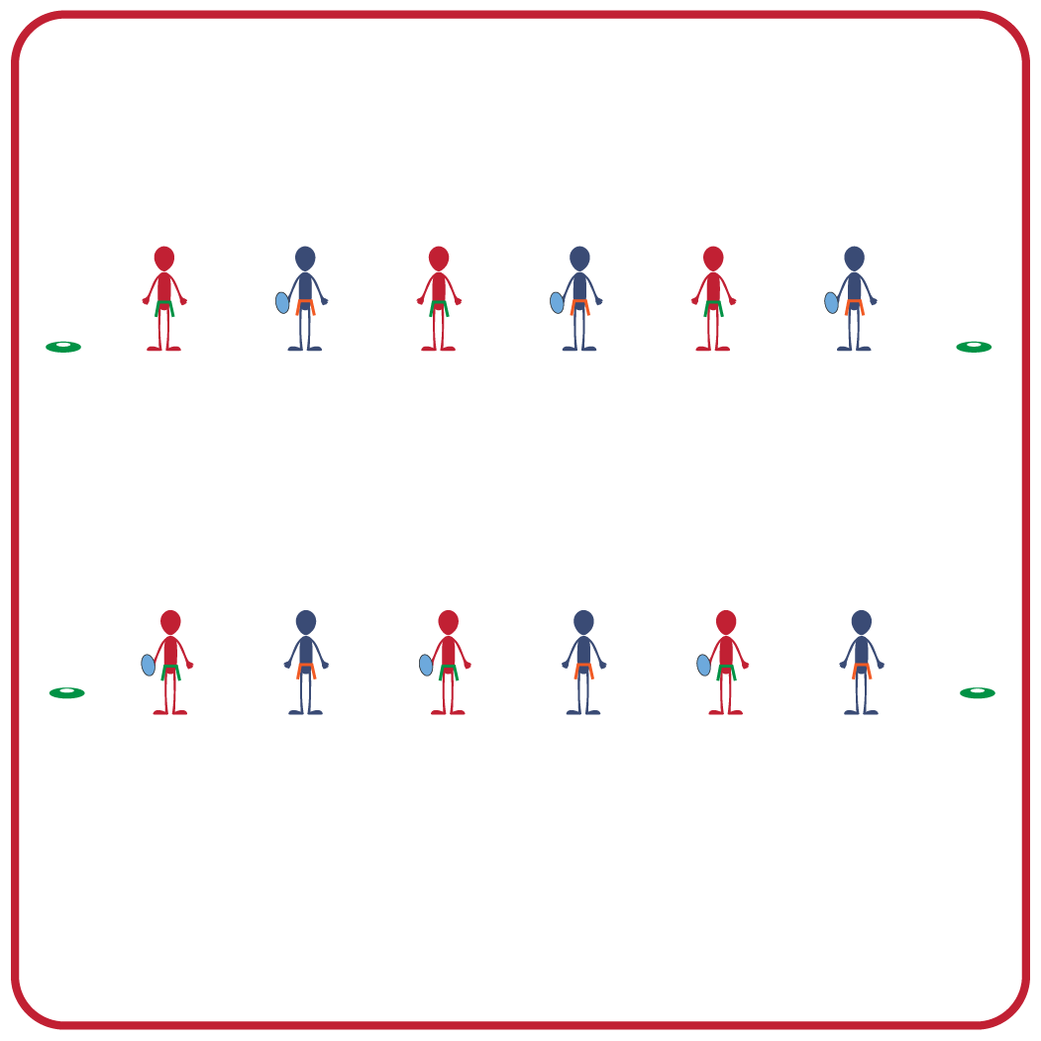
Equipment:
- 1 foam football per 2 students (or other tossable object)
- 4 cones to identify starting lines

Set-Up:
- Create pairs of 2 students.
- Each pair has a foam football (or tossable object of their choice).
- Use 4 cones to identify the two starting lines. The starting lines should be approximately 5 yards apart. Students begin facing their partner, each on one of the starting lines.
ACTIVITY PROCEDURES
- This activity is called 2 Steps Forward, 1 Step Back. The object of this game is to successfully throw and catch the ball with your partner.
- The partner who started with the ball will overhand throw it to their partner. The partner will catch the ball before throwing it back.
- If you are able to successfully throw and catch with your partner 2 times in a row, you will each take 1 step back.
- At any time if the ball is not caught, each partner will take 2 steps forward.
- Teacher Note: set a limit on how far apart the pairs are allowed to get. Once they move 15 yards apart, they remain there while throwing and catching.
- Students who have the ball can move with it, but no more than 5 steps.

GRADE LEVEL PROGRESSION
- Grade 3: Play as described above.
- Grades 4 & 5: Students move 1 step backward or forward after each catch attempt. The maximum distance can be up to 20 yards apart (instead of 15 yards).

TEACHING CUES
- Cue 1: Communicate with your partner using positive language.
- Cue 2: Make sure your partner is looking in your direction before you throw the ball to them. Call out their name so they know the pass is coming to them.
- Cue 3: Have your hands in front of you and watch the ball into your hands, absorbing the catch.
2 STEPS FORWARD, 1 STEP BACK (continued…)

UNIVERSAL DESIGN FOR LEARNING
- UDL 1: Allow students to use tossable objects of different sizes, colors, weights, and textures.
- UDL 2: Decrease the size of the activity space if needed.
- UDL 3: Use peer partners as needed.
- UDL 4: Provide verbal cues and visual demonstrations for each challenge.

ACADEMIC LANGUAGE
Catch, Encourage, Overhand, Safety

PRIORITY OUTCOMES
Manipulative Skills:
- Demonstrates manipulative skills using mature patterns for accuracy and control.

Social Interaction:
- Describes and compares positive social interactions when engaged in partner, small-group, and large group physical activities.

DEBRIEF QUESTIONS
- DOK 1: Describe what a positive social interaction with a partner would look like.
- DOK 2: If you did not feel like you were interacting with your partner in a positive way, how would you communicate with them about it?
- DOK 3: How do interactions with partners or other classmates impact your ability to be successful during a task or a game?

