TOSS 3

STUDENT TARGETS
- Skill: I will accurately toss and catch with a partner.
- Cognitive: I will identify ways to build trust with my teammates.
- Fitness: I will stay actively engaged throughout activity.
- Personal & Social Responsibility: I will demonstrate etiquette and respect in order to work cooperatively with teammates.

EQUIPMENT & SET-UP | 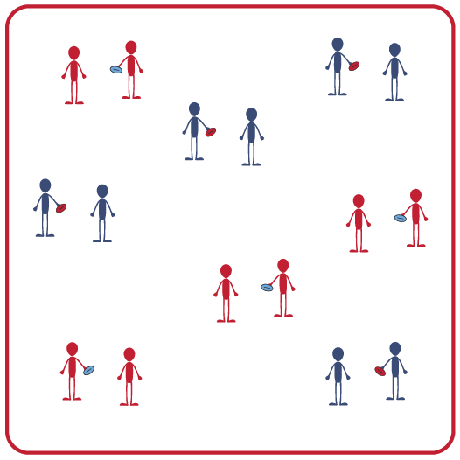
Equipment:
- 1 object per 2 students (e.g., foam ball, bean bag)
- 4 cones
- Music and music player

Set-Up:
- Create a large activity space using 4 cones to mark boundaries.
- Create pairs of students.
- Scatter pairs of students throughout activity area. Each pair with an object.
ACTIVITY PROCEDURES
- Today we’re going to focus on creating open space while overhand tossing and catching with a partner.
- The object of Toss 3 is to work with as many different classmates as you can while the music is playing. When the music starts, the partner with the object will begin with an overhand throw. Each pair will make 3 passes. The partner who now has the object will travel and find a new partner who does not have one. The partner without the object will travel and find a partner who does have one.
- You continue to find a new partner after each set of 3 passes.
- Make sure you are communicating with your classmates while moving to open space when you need a new partner.
- When the music stops be ready for the next set of instructions.

GRADE LEVEL PROGRESSION
- Grade 3: Focus on working with as many different teammates as possible.
- Grades 4 & 5: Discuss using both verbal and non-verbal communication with teammates. Play a round using only non-verbal communication.

TEACHING CUES
- Cue 1: Look at your partner to ensure they are ready before making a toss/pass: their hands are up and their eyes are looking at you.
- Cue 2: Look for both verbal and non-verbal communication from potential partners.
- Cue 3: Try and pass with as many different partners as possible.

TOSS 3 (continued…)

UNIVERSAL DESIGN FOR LEARNING
- UDL 1: Use modified equipment as needed (e.g., foam ball, yarn ball, etc.).
- UDL 2: Use verbal cues and visual aids along with demonstrations.
- UDL 3: Use peer partners as appropriate.
- UDL 4: Modify the size of the activity area as needed.

ACADEMIC LANGUAGE
Etiquette, Cooperation, Communication, Trust

PRIORITY OUTCOMES
Etiquette:
- Exhibits etiquette and adherence to rules in a variety of physical activities.

Working with Others:
- Works cooperatively with others.

DEBRIEF QUESTIONS
- DOK 1: How would you describe proper etiquette in physical education class?
- DOK 2: How does demonstrating etiquette and respect impact trust amongst teammates?

