KEEPER PRACTICE

STUDENT TARGETS
- Skill: I will defend teammates from throwing through the hoop target.
- Cognitive: I will identify defensive strategies that can lead to success with Hoop Ball.
- Fitness: I will be actively engaged during this activity.
- Personal & Social Responsibility: I will use kind words and actions with teammates.

EQUIPMENT & SET-UP | 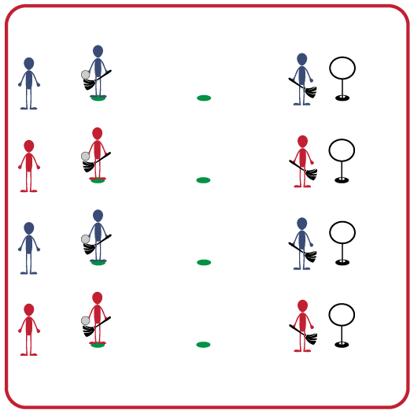
Equipment:
- 1 hoop target per group (hula hoop & slot cones, or a disc golf target)
- 2 brooms per group (pool noodle or slot cone stick)
- 1 quaffle per group (deflated volleyball)
- 2 spot markers per group
Set-Up:
- Create teams of 3 players.
- Each team has a spot marker as the starting spot, a second spot marker to designate where to throw, and a hoop target 5-10 feet from the throwing spot.
- One teammate begins with the quaffle and a broom on the starting spot, second teammate is in front of the hoop target as the defender (also has a broom) and the third teammate is waiting behind the starting spot.
ACTIVITY PROCEDURES
- This activity is called Keeper Practice! We are going to work on our defensive skills for Hoop Ball. The object of the game is to see how many times the defender can prevent the thrower from getting the quaffle through the hoop target.
- Get ready with 1 teammate on the starting spot with a quaffle and broom. The second teammate will be the Keeper, and also have a broom. The Keeper will stand in front of the hoop target as the defender. The third teammate will wait in line behind the leader.
- On the start signal, the first teammate will “fly” with the broom and the quaffle until they get to the throwing spot. They will then attempt to throw the quaffle through the hoop target. The Keeper will work as a defender to prevent the quaffle from making it through the hoop target. After each throw, the Keeper will bring the quaffle and broom back to the starting spot and hand it to their teammate who was waiting.
- Teams will rotate positions and try again. The thrower becomes the Keeper, the Keeper will now wait in line, and the teammate who was waiting in line is now the thrower.

GRADE LEVEL PROGRESSION
- Grades 3-5: Play the activity as described above. Increase or decrease the distance from the throwing spot to the hoop target as needed.
- Grades 6-8: Increase the number of hoop targets for the Keeper to defend.

TEACHING CUES
- Consistent: Throwers must stay focused and apply the cues for throwing during each attempt.
- Defense: Keeper will be in “ready position” in order to move quickly to defend the hoop target.

KEEPER PRACTICE (continued…)

UNIVERSAL DESIGN FOR LEARNING
- UDL 1: Use different types of balls as the quaffle to increase success.
- UDL 2: Increase the size of the hoop target or remove the hoop target altogether if needed.
- UDL 3: Allow for peer partners to work together.
- UDL 4: Use brightly colored cones and equipment to mark the pathways and targets.

ACADEMIC LANGUAGE
Keeper, Defense, Strategy, Target

PRIORITY OUTCOMES
Manipulative Skills:
- Demonstrates control while combining locomotor and manipulative skills in self-space and general space.
- Demonstrates manipulative skills using mature patterns for accuracy and control.

DEBRIEF QUESTIONS
- DOK 1: Can you share what a strategy is?
- DOK 2: What is an example of a defensive strategy that the Keeper needed to use?

