CHASERS VS KEEPERS

STUDENT TARGETS
- Skill: I will make quick transitions from offense to defense during the game.
- Cognitive: I will identify ways to create or close space.
- Fitness: I will be actively engaged during this activity.
- Personal & Social Responsibility: I will show respect for the rules and my teammates during the game.
EQUIPMENT & SET-UP | 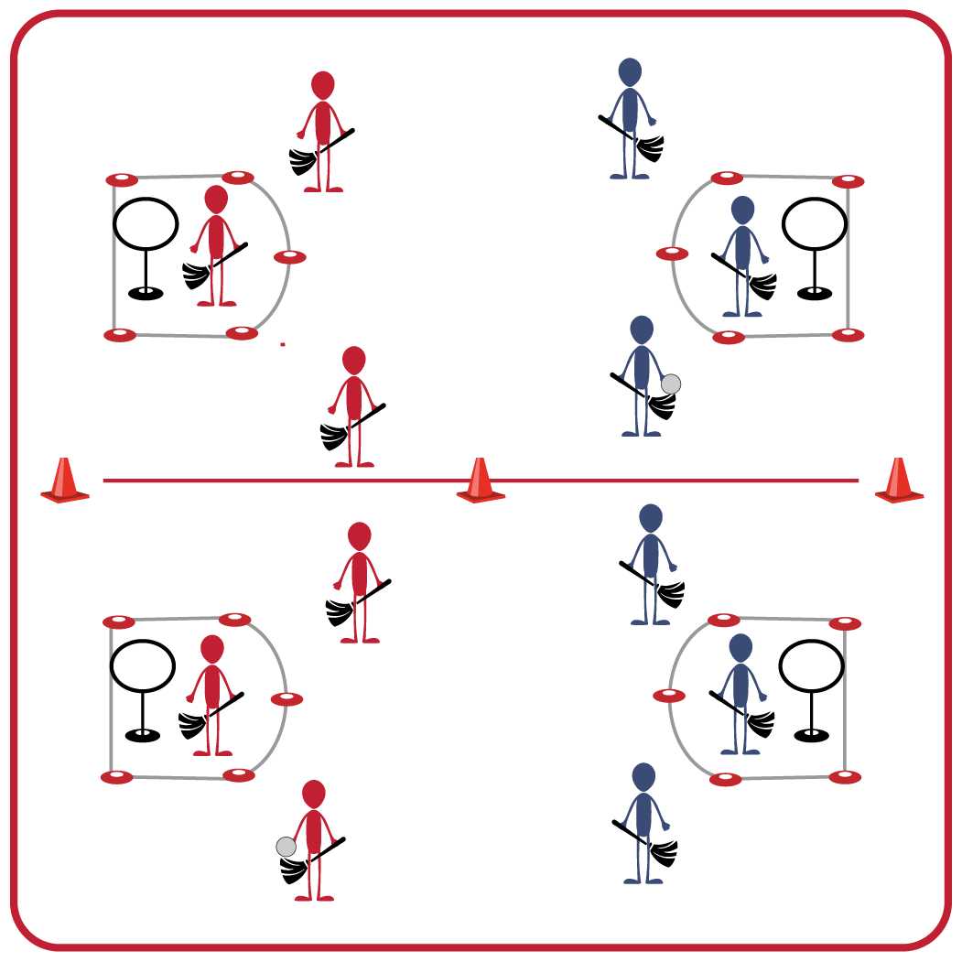
Equipment:
- 2 hoop targets per group (hula hoop & slot cones, or a disc golf target)
- 1 broom per student (pool noodle or slot cone stick)
- 1 quaffle per group (deflated volleyball)
- Spot markers or dome cones for 2 Keeper’s Boxes per group
Set-Up:
- Create groups of 6-8 students, with 2 teams of 3-4 in each group.
- Create a large activity space with grids for each group. Add a hoop target on each end of the grids and use spot markers to create a Keeper’s Box. Use cones to delineate the activity space for each group’s grid.
- Each student begins with a broomstick, and each group begins with a quaffle.
ACTIVITY PROCEDURES
- This activity is called Chasers vs Keepers! We are going to work on our offensive and defensive skills that are needed for Hoop Ball. The object of the game is to try and score points by throwing the quaffle through the hoop target.
- Teams will begin on opposite ends of their activity space facing their opponents. Each student will have a broomstick and teams will play Rock, Paper, Scissors to determine who will begin with the quaffle. One person from each team will begin as the Keeper (and stand in the Keeper’s Box).
- On the start signal, the team beginning on offense with the quaffle will begin moving the ball down the pitch by throwing and catching with teammates as they move towards the hoop target. Offensive players are allowed to pass or run when they have the quaffle.
- Only the designated Keeper for each team is allowed in the Keeper’s Box. Any attempt to throw the quaffle through the hoop target to score must occur from outside of the Keeper’s Box.
- If the ball hits the ground, either team can pick it up and begin moving toward the hoop target to score. Defensive players may attempt to knock the ball out of the hands of the offensive players, however you may not make contact with the player (only the ball).
- After a score, the other team will receive the ball as both teams “reset” and begin in front of their Keeper’s box.
GRADE LEVEL PROGRESSION
- Grades 3-5: Play the activity as described above. Increase or decrease the size of the activity space or Keeper’s Box as needed.
- Grades 6-8: Increase the number of hoop targets for each team.
TEACHING CUES
- Strategy: Work with teammates to close space when on defense and create space when on offense.
- Communication: Make sure you are using verbal and non-verbal communication with your teammates.

CHASERS VS KEEPERS (continued…)

UNIVERSAL DESIGN FOR LEARNING
- UDL 1: Use different types of balls as the quaffle to increase success.
- UDL 2: Increase the size of the hoop target or remove the hoop target altogether if needed.
- UDL 3: Allow for peer partners to work together.
- UDL 4: Use brightly colored cones and equipment to mark the pathways and targets.

ACADEMIC LANGUAGE
Create space, Close space, Offense, Defense

PRIORITY OUTCOMES
Movement Concepts:
- Safely moves demonstrating a variety of relationships with people and objects.
- Recognizes open and closed spaces in a variety of movement contexts.

DEBRIEF QUESTIONS
- DOK 1: What does it mean to be on offense? Defense?
- DOK 2: What is an example of creating space when on offense?
- DOK 2: How could a defender close space when on defense?

