BEATER TAG

STUDENT TARGETS
- Skill: I will safely chase and flee from my classmates.
- Cognitive: I will discuss ways to safely chase, flee, and dodge.
- Fitness: I will be actively engaged during this activity.
- Personal & Social Responsibility: I will follow and apply all safety rules for the game.

EQUIPMENT & SET-UP | 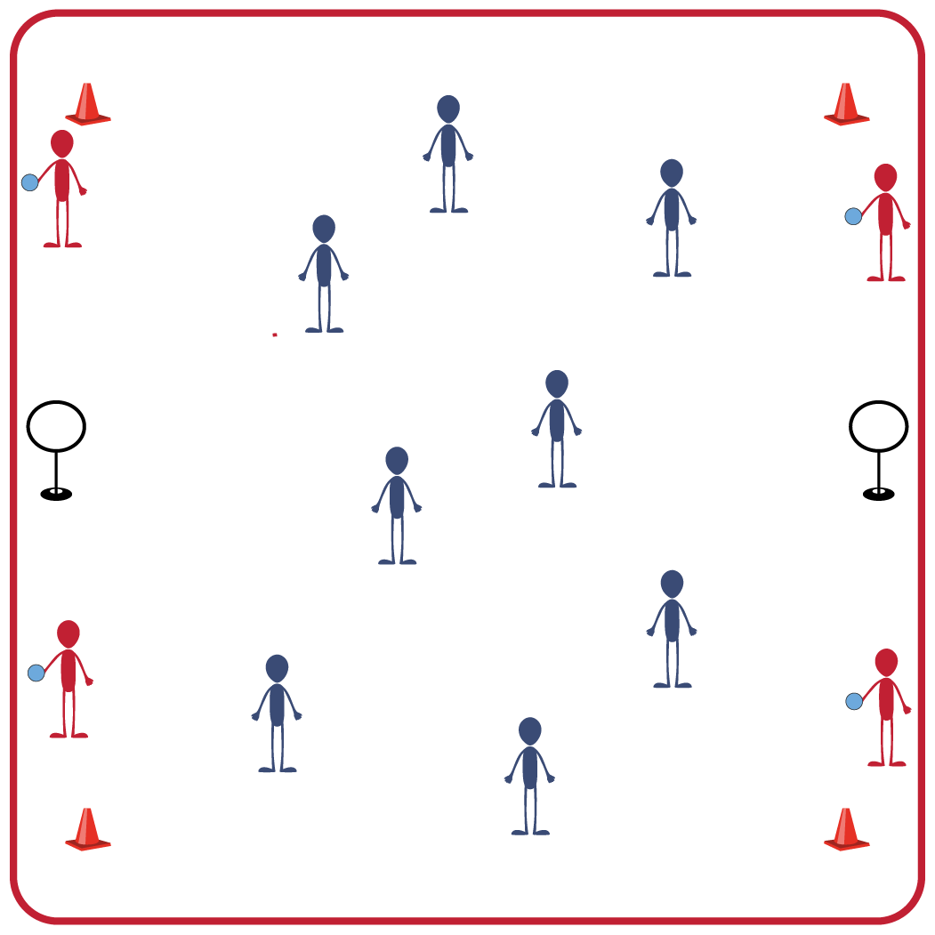
Equipment:
- 4 bludgers (foam balls)
- 4 large cones to identify boundaries
- 2 hoop targets (hula hoop & slot cones, or a disc golf target)

Set-Up:
- Use large cones to set up boundaries for the activity space.
- Identify 4 students as taggers and have them begin outside the boundaries with a bludger (foam ball).
- Set up a hoop target at each end of the activity space (just outside of the boundary cones).
- Remaining students will spread out in general space inside the cones.

ACTIVITY PROCEDURES
- This activity is called Beater Tag! The object of the game is to safely chase or flee from your classmates.
- You will begin by spreading out in general space within the boundary cones. The Beaters (students who were selected as taggers) will begin outside of the boundary cones with a bludger (foam ball).
- On the start signal, the Beaters will do 5 jumping jacks and then begin to chase and tag as many classmates as they can with the bludger (foam ball).
- If you are tagged by a Beater, you will move outside of the boundary cones and gently tap one of the hoop targets before re-entering the game.
- Beaters (taggers) earn 1 point for each classmate they are able to tag!
- When you hear the stop signal we will change taggers and reset to play again.

GRADE LEVEL PROGRESSION
- Grades 3-5: Play as described above.
- Grades 6-8: Have students who are not Beaters (taggers) move with a broomstick (pool noodle). They must keep one hand on the broomstick at all times or it is considered getting tagged.

TEACHING CUES
- Safety: Be mindful of your surroundings while moving inside the boundary to ensure everyone is staying safe while both chasing and fleeing.
- Communication: Use encouraging and positive language with your classmates.
- Etiquette: Be honest if you are tagged and go outside the boundary to touch one of the hoop targets before re-entering the game.

BEATER TAG (continued…)

UNIVERSAL DESIGN FOR LEARNING
- UDL 1: Use brightly colored cones and equipment to mark the activity space and directions.
- UDL 2: Adjust the size of the activity space if needed.
- UDL 3: Allow for peer partners to work together.
- UDL 4: Provide both verbal and visual cues and directions.

ACADEMIC LANGUAGE
Beater, Bludger, Etiquette

PRIORITY OUTCOMES
Etiquette:
- Recognizes the role of rules and etiquette in teacher-designed physical activities.
- Identifies the rules and etiquette for physical activities/games and dance activities.

DEBRIEF QUESTIONS
- DOK 1: What is etiquette?
- DOK 2: Why are rules important during physical activities?
- DOK 3: How do following rules and etiquette for physical activities help keep everyone safe?

