SEEKER VS SNITCH TAG

STUDENT TARGETS
- Skill: I will safely chase and flee from my classmates.
- Cognitive: I will discuss ways to safely chase, flee, and dodge.
- Fitness: I will be actively engaged during this activity.
- Personal & Social Responsibility: I will follow and apply all safety rules for the game.

EQUIPMENT & SET-UP | 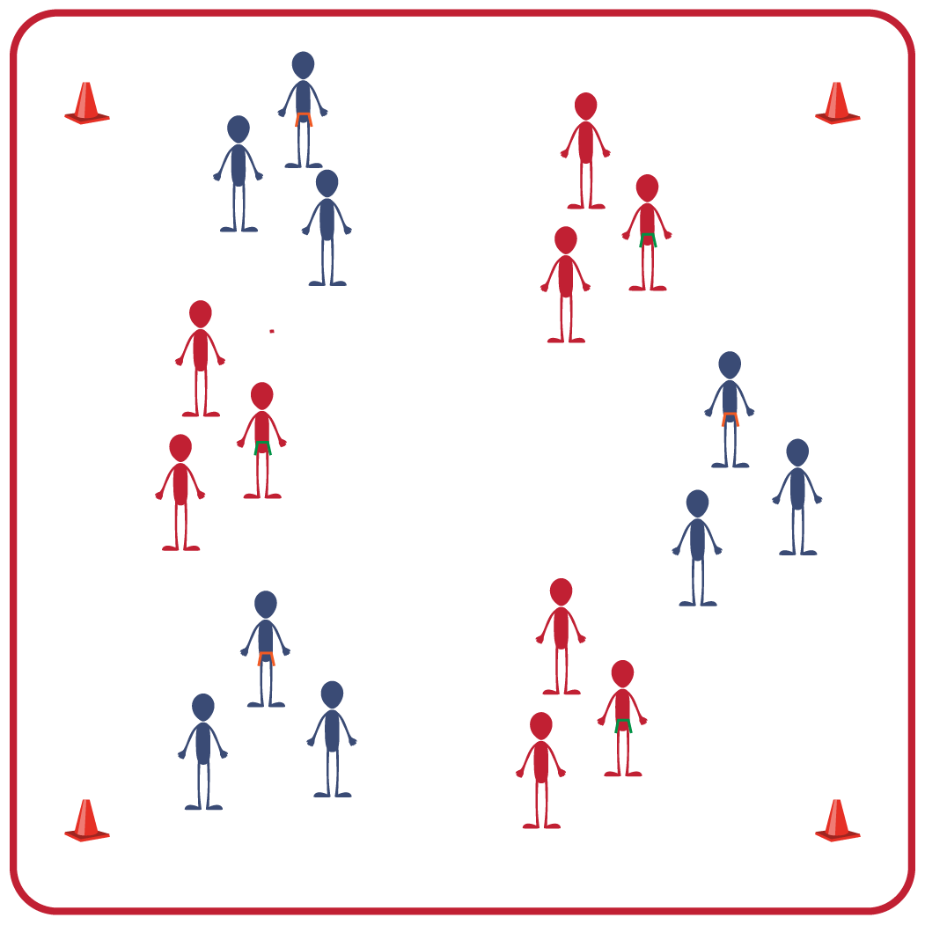
Equipment:
- 1 flag belt or scarf per group
- 4 large cones to identify boundaries

Set-Up:
- Use large cones to set up boundaries for the activity space.
- Create groups of 3-4 students. Each group begins in general space spread out from the other groups.
- Identify the Snitch for each group with a flag belt or scarf.

ACTIVITY PROCEDURES
- This activity is called Seekers vs Snitch Tag! The object of the game is to safely chase or flee from your groupmates.
- You will begin by spreading out with your group in general space within the boundary cones. The Snitches are wearing a flag belt, and the Seekers will be trying to chase and catch the Snitch in their group so they can be the first teammate to pull the flag from the Snitch.
- On the start signal, Seekers will do 5 jumping jacks and then begin to chase the Snitch from their group. Each seeker wants to be the one to pull the flag of the Snitch before the other Seeker.
- If you are able to pull the flag of the Snitch from your group, the Seeker who pulled it now becomes the Snitch and you will play again.
- Seekers earn 1 point for each successful flag pull of a Snitch.
- When you hear the stop signal, we will change roles and reset to play again.

GRADE LEVEL PROGRESSION
- Grade 6: Play as described above.
- Grades 7-8: Have students who are Seekers move with a broomstick (pool noodle). They must keep one hand on the broomstick at all times.

TEACHING CUES
- Safety: Be mindful of your surroundings while moving inside the boundary to ensure everyone is staying safe while both chasing and fleeing.
- Communication: Use encouraging and positive language with your classmates.
- Etiquette: Be honest if your flag is pulled and quickly become the Snitch so your group can re-start the game.

SEEKER VS SNITCH TAG (continued…)

UNIVERSAL DESIGN FOR LEARNING
- UDL 1: Use brightly colored cones and equipment to mark the activity space and identify directions.
- UDL 2: Adjust the size of the activity space if needed.
- UDL 3: Allow for peer partners to work together.
- UDL 4: Provide both verbal and visual cues and directions.

ACADEMIC LANGUAGE
Seeker, Snitch, Honesty, Etiquette

PRIORITY OUTCOMES
Etiquette:
- Recognizes the role of rules and etiquette in teacher-designed physical activities.
- Identifies the rules and etiquette for physical activities/games and dance activities.

DEBRIEF QUESTIONS
- DOK 1: What is honesty?
- DOK 2: How does being honest with teammates about being tagged impact everyone’s enjoyment during the activity?
- DOK 3: How do following rules and etiquette for physical activities help keep everyone safe?

