ORNAMENTS IN THE ATTIC

STUDENT TARGETS
- Skill: I will demonstrate proper form when completing the exercises and movements.
- Cognitive: I will describe what positive social interaction should look like.
- Fitness: I will stay actively engaged throughout activity.
- Personal & Social Responsibility: I will work safely with my partner using positive language.

EQUIPMENT & SET-UP | 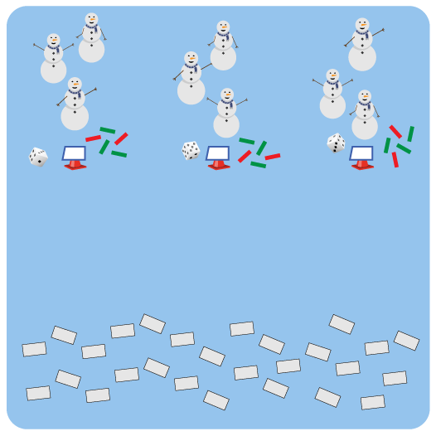
Equipment:
- 1 starting cone, task tent, Relay Activity Card, and die per team
- 5 foam noodles per team (cut or full)
- 1 set of cut out ornaments per team

Set-Up:
- Create groups of 2-3 students.
- Create a starting line of cones with one group at each cone. Place 5 foam noodles, one die, and a task tent with the activity card at each cone.
- Scatter the cut-out ornaments face down on the opposite side of the activity space.
ACTIVITY PROCEDURES
- We are going to decorate a physical education themed holiday tree today!
- The object of the game is to use the foam noodles to build your tree, and then to collect all 8 different ornaments from the attic to decorate the tree.
- On the start signal, your team will use the 5 noodles by your cone to make the branches of your tree.
- Next, one person from each team will roll the die to see what activity your team needs to complete to be eligible to go and collect one ornament. Once your entire team has completed the activity, one teammate will run to the other side of the activity area and collect one ornament.
- Teams place the ornament on your tree, until you have collected all 8 different ornaments. If you choose an ornament you already have, then return it and select a different one.

GRADE LEVEL PROGRESSION
- Grades K-2: Play as described above.
- Grades 3-5: Print out a blank Relay Activity Card, and have the students choose physical activities to add to the card for each number. You can identify a health-related or skill-related fitness component as the focus for each number.

TEACHING CUES
- Cue 1: Communicate with your teammates using positive language.
- Cue 2: Move safely while you travel to collect the ornaments for your team’s tree.
- Cue 3: Only collect one tree ornament at a time.
ORNAMENTS IN THE ATTIC (continued…)

UNIVERSAL DESIGN FOR LEARNING
- UDL 1: Allow students to modify any of the physical activities as needed.
- UDL 2: Decrease the size of the activity space if needed.
- UDL 3: Use peer partners as needed.
- UDL 4: Provide verbal cues and visual demonstrations for each activity on the Relay Activity Card.
- UDL 5: Ensure any assistive technology that is needed by students is available.

ACADEMIC LANGUAGE
Communication, Encourage, Social Interaction

PRIORITY OUTCOMES
Social Interaction:
- Describes and compares positive social interactions when engaged in partner, small-group, and large group physical activities.

DEBRIEF QUESTIONS
- DOK 1: Describe what a positive social interaction with teammates would look like.
- DOK 2: If you did not feel like you were interacting with your teammates in a positive way, how would you communicate with them about it?
- DOK 3: How do interactions with teammates impact your ability to be successful during a task or a game?

