NO GRINCHES ALLOWED

STUDENT TARGETS
- Skill: I will move safely through the activity space demonstrating respect for my classmates.
- Cognitive: I will describe how to demonstrate self-control during the game.
- Fitness: I will stay actively engaged throughout activity.
- Personal & Social Responsibility: I will work safely with my classmates using positive language.

EQUIPMENT & SET-UP | 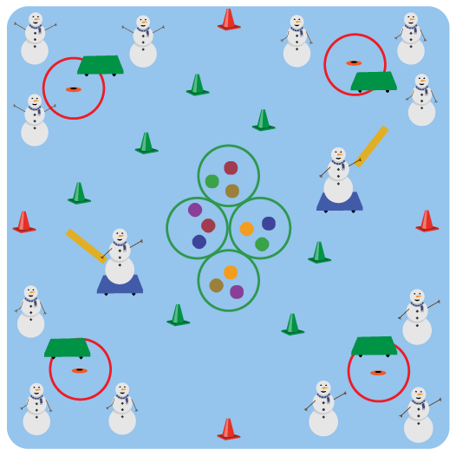
Equipment:
- 1 starting cone, hoop, and scooter per team
- 1 scooter and foam noodle per tagger
- 20-30 Cones (or dome cones)
- Tossables to use as presents (beanbags, yarn balls, foam balls, etc.)
Set-Up:
- Create a large activity circle with cones.
- Place a scooter and a hoop by each cone and have teams of 2-3 students begin at a cone.
- Place the tossables (presents) in several hoops in the center of the activity space, and evenly spread out the cones (trees) inside of activity space.
- Have 2 taggers begin in center of activity space on a scooter, holding a foam noodle to tag with.

ACTIVITY PROCEDURES
- We are going to try and return all of the presents that were stolen by the grinch! The object of the game is to go to the center of the activity area and steal the presents back without being tagged.
- On the start signal, one teammate from each team will use the scooter to try and steal back one present. But be careful, don’t get tagged by the grinches or run into the trees (cones)!
- The grinches (taggers) must stay on their scooters at all times.
- If you make it back to your starting cone without being tagged, place the present you collected in the hoop by your cone and let the next teammate have a turn.
- If you’re tagged, return to your team without a present.
- Continue to rotate trying to steal the presents relay race style until you hear the stop signal.

GRADE LEVEL PROGRESSION
- Grades K-2: Have taggers play without scooters.
- Grades 3-5: Play as described above.

TEACHING CUES
- Cue 1: Communicate with your teammates using positive language.
- Cue 2: Move safely on the scooter while chasing or fleeing from classmates.
- Cue 3: Only collect one present from the middle at a time.

NO GRINCHES ALLOWED (continued…)

UNIVERSAL DESIGN FOR LEARNING
- UDL 1: Allow students to move without a scooter if needed.
- UDL 2: Decrease the size of the activity space if needed.
- UDL 3: Use peer partners as needed.
- UDL 4: Provide verbal cues and visual demonstrations.

ACADEMIC LANGUAGE
Self-Control, Communication, Encourage

PRIORITY OUTCOMES
Personal Responsibility & Safety:
- Follows directions for safe participation and proper use of equipment without reminders.
- Engages in physical activity with responsible interpersonal behavior (e.g., peer to peer, student to teacher).

DEBRIEF QUESTIONS
- DOK 1: Describe what it means to demonstrate self-control.
- DOK 2: What is an example of how a tagger may need to show self-control?
- DOK 2: What is an example of how someone trying to steal the presents back may need to show self-control?

