SNOWMAN & SUNSHINE TAG

STUDENT TARGETS
- Skill: I will increase my heart rate to improve my fitness.
- Cognitive: I will describe what cardiorespiratory endurance is.
- Fitness: I will stay actively engaged throughout activity.
- Personal & Social Responsibility: I will work safely with my partner using positive language.

EQUIPMENT & SET-UP | 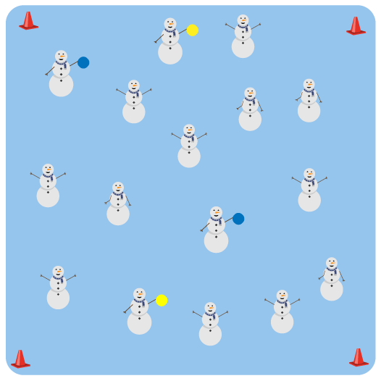
Equipment:
- 4 cones to create boundaries
- 2-3 yellow foam balls to identify the taggers
- 2-3 blue foam balls to identify the freezers

Set-Up:
- Create a large playing area using the 4 cones.
- Scatter students in the activity area.
- Identify 2-3 taggers by giving them the yellow foam balls.
- Identify 2-3 freezers by giving them the blue foam balls.
ACTIVITY PROCEDURES
- This activity is called Snowman & Sunshine Tag.
- On the start signal, we will begin moving at a speed-walking pace. Taggers will do 10 jumping jacks to give you time to move away. The taggers are the “suns” (with a yellow foam ball) looking to melt the snow people of the North Pole (rest of the class).
- If a snow person is tagged by the sunshine, they will stop moving and begin to melt by performing a sun salutation.
- Continue melting (sun salutation) until a student with a blue foam ball comes along and refreezes you.
- Activity will continue until you hear the stop signal. We will change taggers and freezers and begin again.

GRADE LEVEL PROGRESSION
- Grades K-2: Play as described above.
- Grades 3-5: Use different locomotor movements such as skipping or jogging when the music begins. Announce a different locomotor movement each time a new round of the game begins.

TEACHING CUES
- Cue 1: Communicate with your classmates using positive language.
- Cue 2: Move with control while chasing or fleeing from your classmates.
- Cue 3: Be aware of your surroundings to help keep everyone safe while moving. This includes looking where you are going in order to not bump into your classmates.

SNOWMAN & SUNSHINE TAG (continued…)

UNIVERSAL DESIGN FOR LEARNING
- UDL 1: Allow students to modify any of the locomotor movements as needed.
- UDL 2: Decrease the size of the activity space if needed.
- UDL 3: Use peer partners as needed.
- UDL 4: Provide verbal cues and visual demonstrations.

ACADEMIC LANGUAGE
Communication, Cardiorespiratory Endurance, Fitness

PRIORITY OUTCOMES
Fitness Knowledge:
- Recognizes that when you move fast, your heart beats faster and you breathe faster.
- Identifies physical activities that contribute to fitness.

DEBRIEF QUESTIONS
- DOK 1: Describe what cardiorespiratory endurance is.
- DOK 2: What happened to your breathing as you moved faster during the tag game? Why?
- DOK 3: What are some other physical activities that could help improve your cardiorespiratory endurance?

