SNOWFLAKE MAPS

STUDENT TARGETS
- Skill: I will cooperate with my partner to complete the snowflake map.
- Cognitive: I will describe what positive language sounds like.
- Fitness: I will stay actively engaged throughout activity.
- Personal & Social Responsibility: I will work safely with my partner using positive language.

EQUIPMENT & SET-UP | 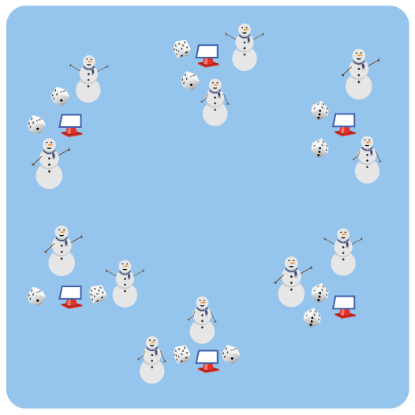
Equipment:
- 6 cones with task tents
- Snowflake Station Cards
- Snowflake Map Sheet and Pencil (1 per pair)
- 12 to 24 Dice

Set-Up:
- Use 6 cones and task tents to create a large circle in the activity area. Place Snowflake Station Cards in task tents.
- Distribute dice evenly to each cone (2 to 4 dice per cone)
- Place Snowflake Map Sheets and pencils on the perimeter.
- Pair students. Pairs can begin at any cone.
ACTIVITY PROCEDURES
- Today we will create Snowflake Maps for the reindeer to travel when delivering presents.
- The object of this activity is to create a snowflake map by moving from cone to cone, remembering and then recording your pathway.
- On the start signal, complete the Snowflake Task on the station card at your cone. Then, roll the dice to see which station you will go to next. For example, if you roll a 4 you will go to Snowflake Station Number 4. Roll again if you roll the number of the station where you currently are.
- Complete the exercise at the station before rolling the dice at that cone and continuing.
- Once you and your partner have rolled the dice 12 times, stop and get a snowflake map template and pencil. Now draw a line from cone to cone on the sheet, remembering the path you traveled.
- When finished, compare maps with others. No 2 maps are the same, just like no 2 snowflakes are the same!

GRADE LEVEL PROGRESSION
- Grades K-2: Have students map their pathway each time they roll the dice versus having to remember their pathway and map it at the end of the 12 dice rolls.
- Grades 3-5: Play as described above. Students could create their pathway on foot or on scooters.

TEACHING CUES
- Cue 1: Communicate with your teammates using positive language.
- Cue 2: Move safely while you travel to complete your snowflake map.
- Cue 3: Work cooperatively with your partner to remember your pathway.
SNOWFLAKE MAPS (continued…)

UNIVERSAL DESIGN FOR LEARNING
- UDL 1: Allow students to modify any of the physical activities as needed.
- UDL 2: Decrease the size of the activity space if needed.
- UDL 3: Use peer partners as needed.
- UDL 4: Provide verbal cues and visual demonstrations for each activity on the Snowflake Station Card.
- UDL 5: Ensure any assistive technology that is needed by students is available.

ACADEMIC LANGUAGE
Communication, Encourage, Social Interaction

PRIORITY OUTCOMES
Social Interaction:
- Describes and compares positive social interactions when engaged in partner, small-group, and large group physical activities.

DEBRIEF QUESTIONS
- DOK 1: How can you recognize positive language?
- DOK 2: What did you notice when you used positive language with your partner?
- DOK 3: How is positive language related to building good relationships with classmates?

