RED NOSE RELAY

STUDENT TARGETS
- Skill: I will cooperate with my teammates to move the ball quickly and safely.
- Cognitive: I will describe the benefits of cooperating with my teammates.
- Fitness: I will stay actively engaged throughout activity.
- Personal & Social Responsibility: I will communicate with my teammates using positive language.

EQUIPMENT & SET-UP | 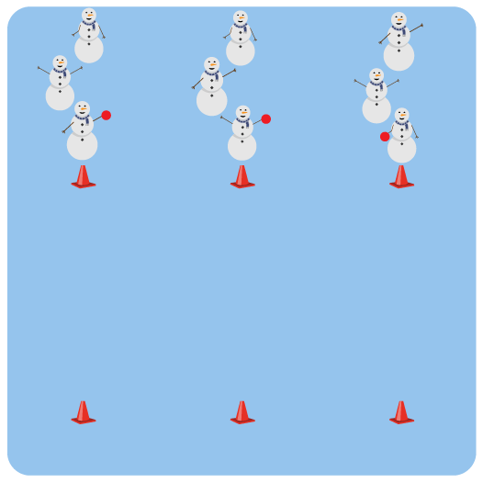
Equipment:
- 12 cones
- 6 red foam balls

Set-Up:
- Create team relay lines using 6 cones.
- Place the remaining 6 cones in a parallel line on the opposite side of the activity area.
- Divide students into 6 teams; each team at a cone with 1 red foam ball.
ACTIVITY PROCEDURES
- It’s time for a Red Nose Relay! The reindeer in front of your line will have the red ball (Rudolph’s nose). Rudolph’s nose must always stay in the front of the line to light the way for the reindeer.
- On the start signal, the reindeer at the back of the line will run to the front of the line. The reindeer with Rudolph’s nose will pass it to the new line leader to light the way.
- As soon as the new line leader has Rudolph’s nose, they will yell “GO!” The reindeer at the back of the line will then run to the front.
- Continue until your team travels down to the chimney (to the opposite cone) and back.
- The first team to complete the relay wins!

GRADE LEVEL PROGRESSION
- Grades K-2: Play as described above but decrease the distance between the cones.
- Grades 3-5: Play as described above.

TEACHING CUES
- Cue 1: Communicate with your teammates using positive language.
- Cue 2: Move quickly but safely when moving with your team.
- Cue 3: Work cooperatively with your teammates to move the ball.
RED NOSE RELAY (continued…)

UNIVERSAL DESIGN FOR LEARNING
- UDL 1: Allow students to modify any of the locomotor movements as needed.
- UDL 2: Decrease the size of the activity space if needed.
- UDL 3: Use peer partners as needed.
- UDL 4: Provide verbal cues and visual demonstrations for each activity on the Relay Activity Card.

ACADEMIC LANGUAGE
Communication, Cooperation, Safety

PRIORITY OUTCOMES
Working with Others:
- Works cooperatively with others.
- Shares equipment and space with others.

DEBRIEF QUESTIONS
- DOK 1: Give an example of how your team used communication skills in this activity.
- DOK 2: How did communication affect your team’s ability to move quickly?
- DOK 3: How is communication related to teamwork?

