SNOWMAN BUILDERS

STUDENT TARGETS
- Skill: I will move safely through the activity space demonstrating respect for my classmates.
- Cognitive: I will describe how to use positive language with my partner.
- Fitness: I will stay actively engaged throughout activity.
- Personal & Social Responsibility: I will work safely with my classmates using positive language.

EQUIPMENT & SET-UP | 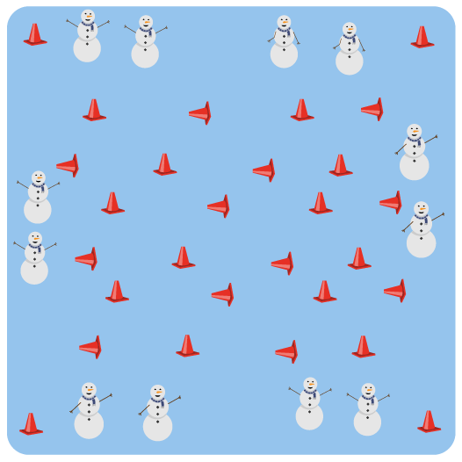
Equipment:
- As many medium sized cones as possible
- 4 large cones to identify boundaries

Set-Up:
- Divide the class in half and create two teams.
- Scatter cones throughout the activity space, with half of them standing up and half of them laying on their side (knocked over).
- Set up a boundary around the perimeter of the activity space with 4 large cones.
- Students will begin outside of the boundary markers, spaced safely apart from each other.
ACTIVITY PROCEDURES
- This activity is called Snowman Builders! The object of the game is to either stand up or knock down as many snowmen (cones) as you can for your team. You do that by safely using one hand to either pick up or knock down a cone, depending on what role your team has been assigned.
- One team will be the snowplows, who will be trying to knock down as many snowmen (cones) as they can while the music plays. The other team will be the snowman builders, and they will be standing up as many cones (to build the snowmen) as possible while the music plays.
- When the music starts, the snowplows will begin using one hand to knock cones over and builders will work to stand up the cones as all of you move safely through the activity space.
- When the music stops, we will work together to count how many cones are standing up and how many are knocked down. The team with the most cones up or down wins!
- We will switch roles for the second round before we play again.

GRADE LEVEL PROGRESSION
- Grades K-2: Play as described above.
- Grades 3-5: Increase the size of the activity space and the speed that students are allowed to move during the activity.

TEACHING CUES
- Cue 1: Communicate with your teammates using positive language.
- Cue 2: Move safely and look out for others as you knock down or build the snowmen.

SNOWMAN BUILDERS (continued…)

UNIVERSAL DESIGN FOR LEARNING
- UDL 1: Allow students to change the locomotor movements if needed.
- UDL 2: Decrease the size of the activity space if needed.
- UDL 3: Use peer partners as needed.
- UDL 4: Provide verbal cues and visual demonstrations.

ACADEMIC LANGUAGE
Communication, Encourage, Praise

PRIORITY OUTCOMES
Social Interaction:
- Describes the positive social interactions that come when engaged with others in physical activity.

DEBRIEF QUESTIONS
- DOK 1: What does positive and encouraging communication sound like?
- DOK 2: What is an example of positive or encouraging communication you heard during the game?
- DOK 3: How does positive and encouraging communication impact the way a team interacts and works together?

