SNOWMAN CONSTRUCTION CREW

STUDENT TARGETS
- Leadership: I will show others how to follow rules and be a good example during class activities.
- Kindness: I will use kind words when talking to my classmates.

EQUIPMENT & SET-UP | 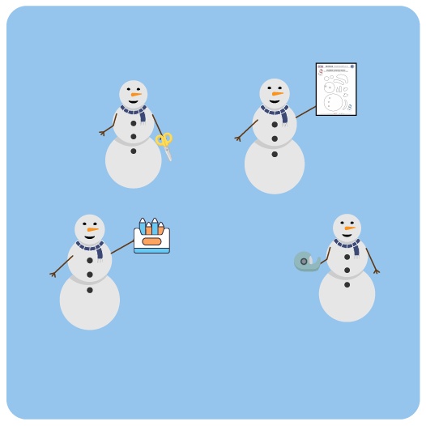
Equipment:
- 1 Snowman Construction Kit per group
- 1 Snowman Birth Certificate per student
- Tape / adhesive / stapler for posting snowmen
- Construction Paper or Posterboard
- Box of crayons per group

Set-Up:
- Create groups of 4 to 6 students.
- Give 1 snowman construction kit and box of crayons to each group.
- Create a Snowman Championships bulletin board for students to post their snowmen. Use posterboard if a bulletin board is not available.
ACTIVITY PROCEDURES
- This activity is Snowman Construction Crew. The object of this activity is to work as a team to create a fun and friendly snowman that will hang on our bulletin board.
- We will take 10 minutes (or more) to create our snowmen using a Snowman Construction Kit.
- You will use crayons to color in the pieces of your snowman. Once the pieces are prepared, you’ll take turns posting the snowman on the bulletin board.
- If there’s time after your group is done with construction, use the Snowman Birth Certificate to write about your snowman.
- Teacher Note: you can decide to have groups complete the snowman birth certificates individually, as a group, or complete them as a class.

DEBRIEF QUESTIONS
- DOK 1: What is one example of a way you can be a leader?
- DOK 2: How can a leader help others during a partner/group activity?
- DOK 3: If a leader uses kind words when talking with you, how does that impact your willingness to follow them? Why?

TEACHING TIPS
- TIP 1: Have pre-determined areas within the classroom for each group of students to work based on the number of groups you will have.
- TIP 2: The snowmen created during this activity will be displayed on your Snowman Championships bulletin board. Please note, snowflakes will be created in activity 3 that will also be displayed on this bulletin board. Plan the spacing of the snowmen to allow for the snowflakes that will be added after activity 3.
- TIP 3: Share the directions verbally as well as provide a visual example of a completed Snowman before students begin the activity.

