SNOWMAN STORYTIME

STUDENT TARGETS
- Leadership: I will lead by example by following all instructions and participating in a meaningful and fun way.
- Kindness: I will listen to my partner and use encouraging words when we talk to each other.

EQUIPMENT & SET-UP | 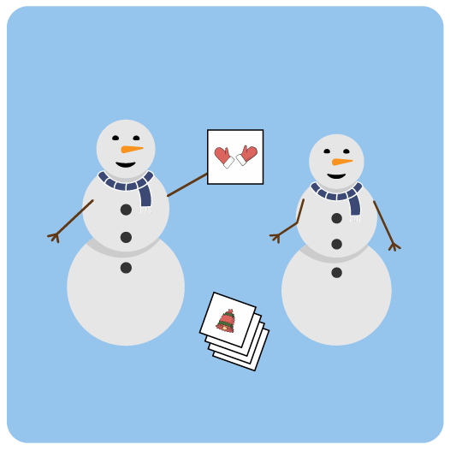
Equipment:
- 3 to 5 Snowman Story Cards per pair
- Snowman Story Cover

Set-Up:
- Pair students. Each pair with enough space to talk to each other and move safely.
- Give each pair 3 to 5 Story Cards.
ACTIVITY PROCEDURES
- It’s time to be creative with an activity called Snowman Storytime. The object of this game is to tell a fun story with your partner’s help using the Snowman Story Cards.
- When I say, “GO!” you and your partner will flip over the top story card in your pile. You must use the object on the card in your story. One partner will begin as the storyteller, the other will be the active listener.
- When you hear me say, “Snowman Switcharoo!” you and your partner will change roles. The storyteller will become the active listener and the active listener will become the storyteller.
- When you hear me say, “Plot Twist!” you and your partner will choose a new card from your pile and continue the story using that new object.
- If there’s time after you and your partner tell your story, use the Snowman Story Cover to draw a scene from your story.
- Teacher Note: If possible, have students stand and face each other with the active listener doing a light physical activity – like marching in place.

DEBRIEF QUESTIONS
- DOK 1: What does it mean to lead by example?
- DOK 2: Why is it important for a leader to use encouraging words and listen to others?
- DOK 3: What might happen if a leader isn’t fair or respectful?

TEACHING TIPS
- TIP 1: Determine if space available allows for the active listener to do a light physical activity. If so, have a list of physical activity options ready that can be done safely in your teaching space.
- TIP 2: Discuss some examples of words that students could use to begin their stories before beginning the activity.
- TIP 3: Assign a peer partner if needed to assist with reading the Story Cards or with performing the physical activities.

