SNOWMAN ACTS OF KINDNESS

STUDENT TARGETS
- Leadership: I will share my ideas with confidence while also listening to the ideas of others.
- Kindness: I will identify acts of kindness that my classmates and I can do for friends and family.

EQUIPMENT & SET-UP | 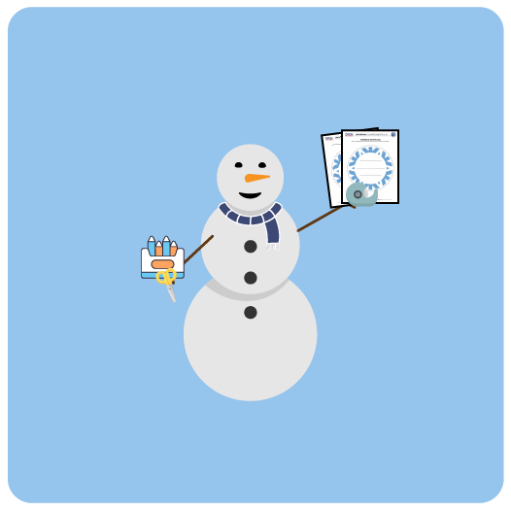
Equipment:
- 2 Kindness Snowflake Pages per student
- Crayons and scissors

Set-Up:
- Students work independently at their desk.
- Give each student 2 Kindness Snowflake pages.
ACTIVITY PROCEDURES
- It’s time for us to create a snowstorm with Snowman Acts of Kindness. Before we begin creating all of the snowflakes in the snowstorm, let’s make a list of kind things that you think friendly and helpful snowmen might do for their friends and family.
- Teacher Note: coach students through the process of discussing and listing a variety of acts of kindness.
- Now that we have a complete list, let’s create our snowstorm. Everyone has 2 snowflake pages. You will write one Snowman Act of Kindness on each snowflake. You can choose from the list that we made, or you can think of another act of kindness. You can decorate and then cut out your snowflake when you’re done writing.
- Once we create all of our snowflakes, we’ll decorate our snowman bulletin board to create a snowstorm of kindness!

DEBRIEF QUESTIONS
- DOK 1: What does it mean to be kind to someone?
- DOK 2: How can using kind words or doing acts of kindness make someone feel?
- DOK 3: What is one way you could show kindness to someone who seems left out?

TEACHING TIPS
- TIP 1: Discuss some examples of acts of kindness with students before they begin the activity.
- TIP 2: Offer the option for students to dictate what they want on their snowflake to another student or an adult who can assist with writing it for them.
- TIP 3: The snowflakes created during this activity will be displayed on the Snowman Championships bulletin board. They will be added to the snowmen that were created and displayed from activity 1.

