SNOWBALL TOSS

STUDENT TARGETS
- Leadership: I will identify ways to show leadership with my partner during this activity.
- Kindness: I will notice and say “thank you” when my partner does something kind or encourages me during the activity.

EQUIPMENT & SET-UP | 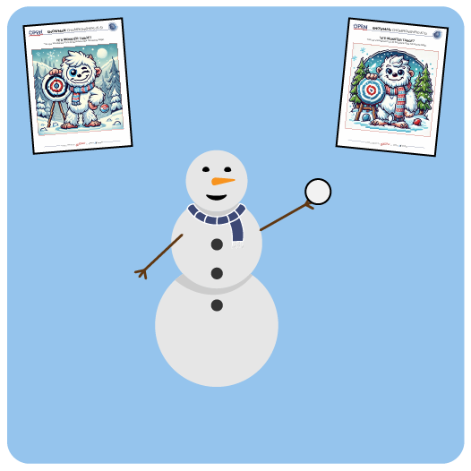
Equipment:
- 1 white yarn ball, fleece ball, rolled up sock, or paper ball per student
- 1 Yeti Monster Target per pair of students

Set-Up:
- Place Yeti Monster Targets throughout the classroom. Place the targets in safe locations where it’s okay for students to toss the “snowballs” at it. Hang on a wall, lay flat on the floor, or place on top of a desk.
- Each student has a “snowball.”
- Students are in pairs near a target.
ACTIVITY PROCEDURES
- It’s time for a Snowball Toss. The object of this game is to hit the Yeti Monster as many times as you can in 1 minute.
- Play Rock, Paper, Scissors to determine who will toss first.
- When the music starts, the first player will toss both snowballs (one at a time) at your Yeti Monster Target. As soon as both snowballs are tossed, that player will move to collect the snowballs so that the next player can toss.
- Continue taking turns until the music stops.
- Each time you toss safely toward the target you get 1 point. Each time you hit the target you get 5 points. You and your partner are working together – so keep track of your team score!
- Once we have our first round score, we’ll play round two and try to beat our score.

DEBRIEF QUESTIONS
- DOK 1: What is an example of a way to show leadership?
- DOK 2: How could a leader respond if they see someone being kind or encouraging someone?
- DOK 3: How could a leader respond with kindness, even if they are upset themselves?

TEACHING TIPS
- TIP 1: Map out how to arrange the pairs of students a safe distance apart in your teaching space prior to this activity.
- TIP 2: Discuss using different amounts of force depending on the weight of the object they are tossing and the distance to the Yeti Monster Target.
- TIP 3: Offer a variety of different objects to toss, and allow students to choose the object they can be most successful with.

