SNOWMAN TEAM CHEER

STUDENT TARGETS
- Leadership: I will work together with my classmates to complete the task of creating our team cheer.
- Kindness: I will be respectful and listen to others while discussing all suggestions and opinions during the creation of our team cheer.

EQUIPMENT & SET-UP | 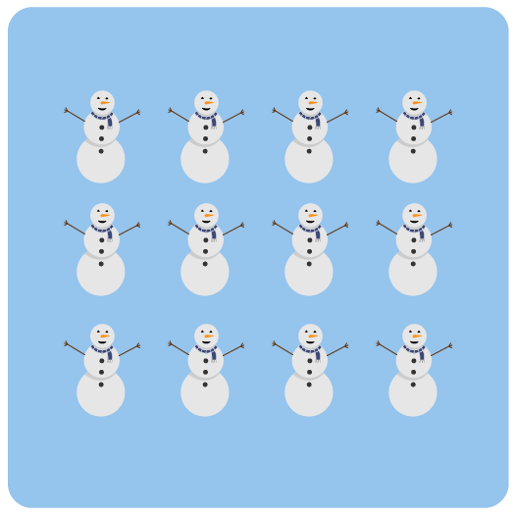
Equipment:
- 1 Snowman Team Cheer Chart per class

Set-Up:
- This is a whole class activity. Students can work in their seats – ready for a class discussion.
ACTIVITY PROCEDURES
- It’s time to create a Snowman Team Cheer for our class. We’ll perform our cheer all next week and for the entire school at our Snowman Championship PEP Rally at the end of next week.
- Teacher Note: Use the Snowman Team Cheer Chart and rubric to guide the class discussion.
- Now that we’ve created our cheer, let’s practice!
- For the next week, any time our class witnesses an act of kindness or leadership, we’ll put a tally mark on our board. Every time we collect 5 tally marks, we’ll perform our cheer!

DEBRIEF QUESTIONS
- DOK 1: What does it mean to be respectful of others?
- DOK 2: Do you think it is easier for a group of people to complete a task if everyone is respectful to others while they are working together? Why or why not?
- DOK 3: Why is it important for a leader to listen and be respectful of others during a discussion?

TEACHING TIPS
- TIP 1: Before introducing the activity, set up some “ground rules” for how a respectful discussion can occur where everyone has an opportunity for their suggestions to be heard.
- TIP 2: Write down (or type) and display the suggestions from students as they are discussed to allow both visual and auditory learners to better follow along and participate in the discussion. This can be done by a student or an adult.

