SNOWMAN ARTWORK SHOWCASE

STUDENT TARGETS
- Leadership: I will discuss ways that leaders can be inspirational.
- Kindness: I will discuss how a kind act can inspire others to also show kindness.

EQUIPMENT & SET-UP | 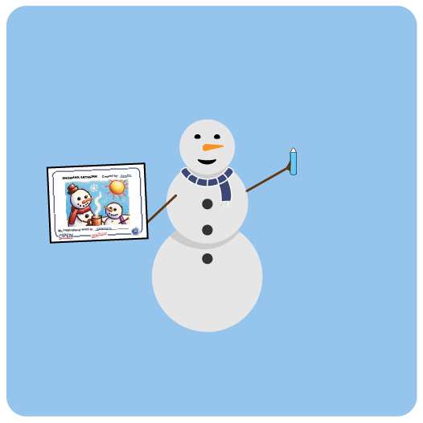
Equipment:
- 1 Snowman Artwork Page per student
- Snowman Kindness & Leadership Word Cards
- Crayons

Set-Up:
- Students work independently at their desks.
- Give each student a Snowman Artwork Page.
- Display Word Cards for students to see and discuss.
ACTIVITY PROCEDURES
- It’s time for us to create Snowman Artwork that we can showcase in the hallway outside of our classroom (or inside if the hallway is not a possibility).
- Each piece of artwork will be inspired by a word that is related to kindness or leadership. You will write your chosen word at the bottom of your artwork page.
- Before we begin creating our artwork, let’s review a list of words that we can use for inspiration.
- Teacher Note: have a class discussion about each word on the list.
- Now that we have discussed each word, let’s create our artwork.
- Everyone has a Snowman Artwork Page. You will choose one inspirational word and write it on the bottom of your page. Then, you’re going to create Snowman Art that represents what this word means to you.
- Once we create our artwork, we’ll hang all of our work in the hallway for the entire school to see.

DEBRIEF QUESTIONS
- DOK 1: What were some words we discussed that you felt were related to kindness? Which ones did you feel were related to leadership?
- DOK 2: What are some ways that a leader can be inspirational?
- DOK 2: What are some acts of kindness that could potentially inspire others to also show kindness?

TEACHING TIPS
- TIP 1: In addition to the list of words provided, have students discuss and brainstorm other potential words related to leadership or kindness.
- TIP 2: If technology is available, students could create their Snowman Art on a device or on the artwork page provided.
- TIP 3: Share the directions verbally as well as provide a visual example of a completed Snowman Artwork Page before students begin the activity.

