SNOWMAN GROUP REFLECTION

STUDENT TARGETS
- Leadership: I will follow all instructions and rules to set an example for my classmates.
- Kindness: I will listen to my partner and use encouraging words when we talk to each other.

EQUIPMENT & SET-UP | 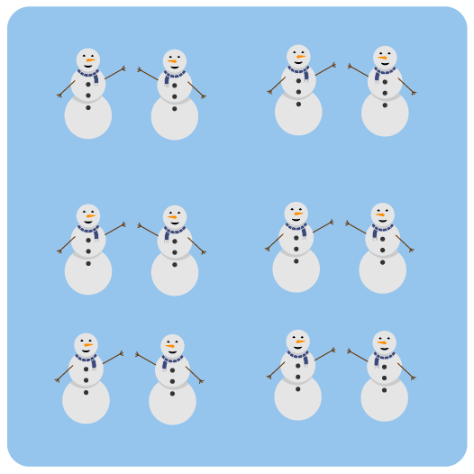
Equipment:
- 1 set of Snowman Reflection Question Strips
- Pencils, pens, markers, or crayons

Set-Up:
- Cut out the Snowman Reflection Questions and shuffle them in a hat or box.
- Students work in pairs for Think-Pair-Share.

ACTIVITY PROCEDURES
- Today is the final day of the Snowman Championships! Everyone has done an amazing job and I’m very proud of you. Let’s take just a few minutes to think about and reflect on what we’ve learned in the past 2 weeks.
- I’m going to pull a reflection question from the box. We’re going to do this in Think-Pair-Share format. Right after I read a reflection question, you’ll have 1 minute to think quietly about your thoughts and feelings related to this question. Next, you’ll have 2 minutes to pair with your partner and talk about your thoughts. Finally, pairs will share their thoughts with the rest of the class in a group discussion.
- We’ll pull as many questions as we can in the time that we have.

DEBRIEF QUESTIONS
- DOK 1: How can your actions set an example for others?
- DOK 2: Why is it important to use encouraging words and actively listen to others?
- DOK 3: What might happen if we don’t speak to our friends and family in a way that is encouraging and respectful?

TEACHING TIPS
- TIP 1: Have students pair up with a new partner for each question that is discussed.
- TIP 2: Allow students to have a peer partner if needed that can assist with the questions or with moving safely in the classroom to pair with their partner(s).

