 | SNOWMAN  BIRTH CERTIFICATE
Color your snowman and give it a name.

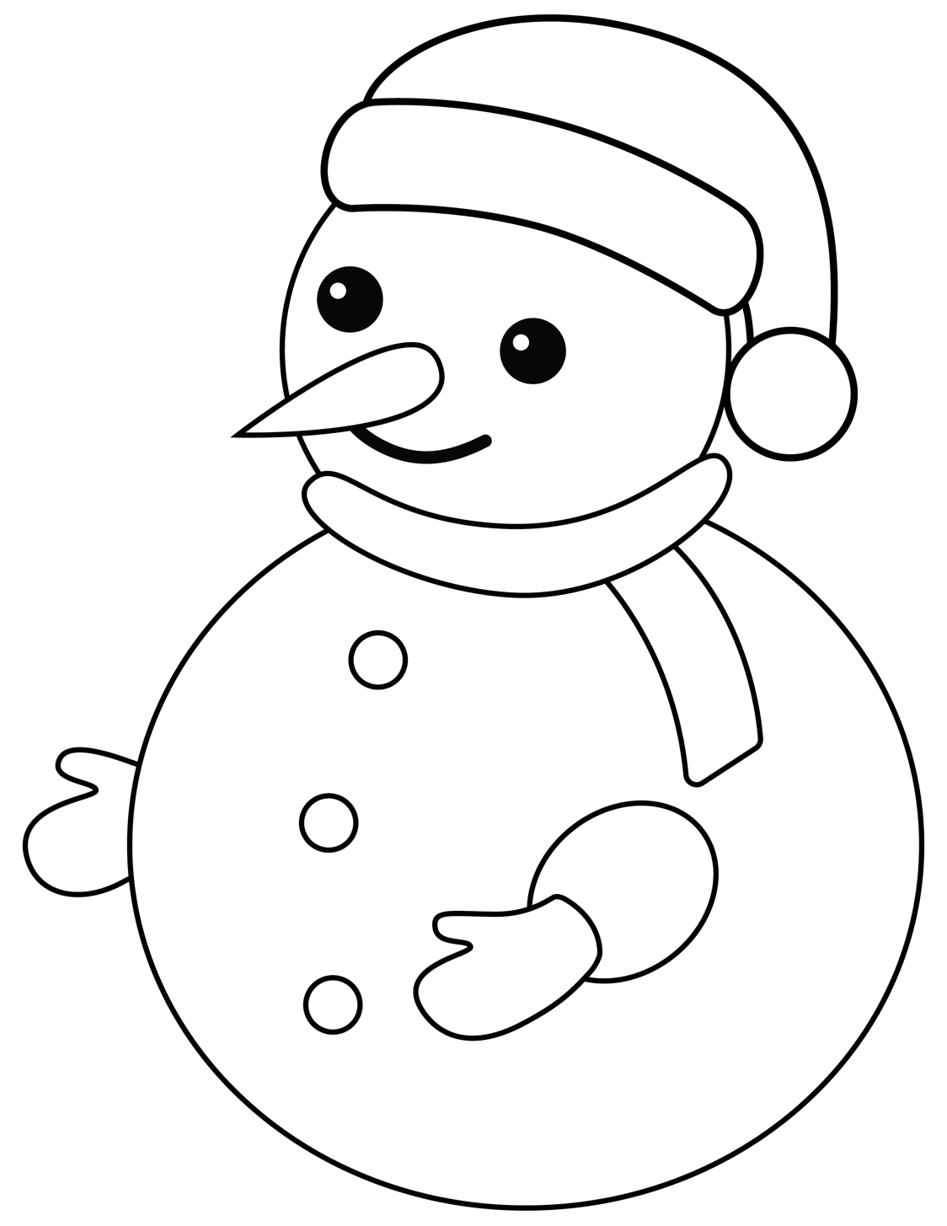

Snowman Name:
Birthdate:
Snowman Creator:

