**YETI MONSTER TARGET**

Toss your snowball and try to hit the picture of the Yeti and the target.

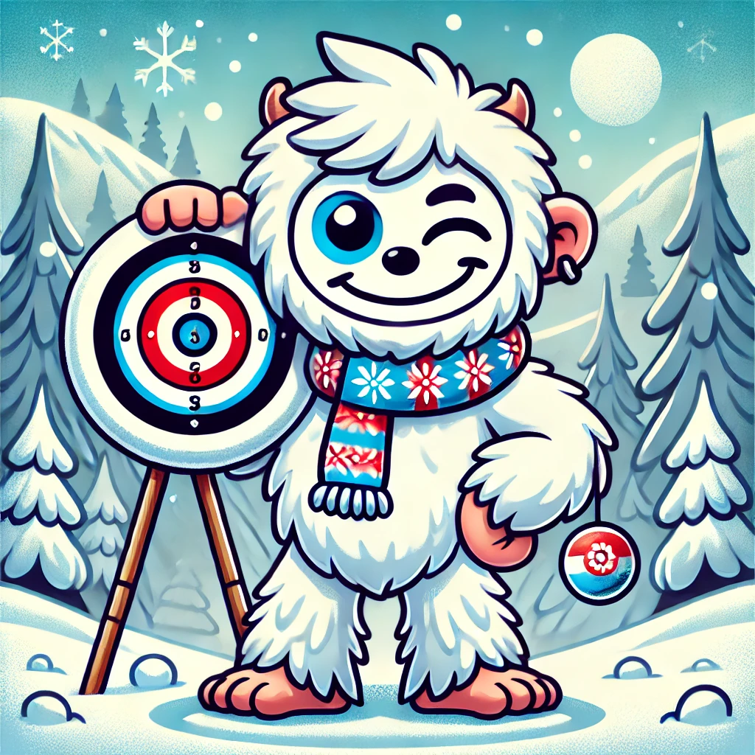

**YETI MONSTER TARGET**

Toss your snowball and try to hit the picture of the Yeti and the target.

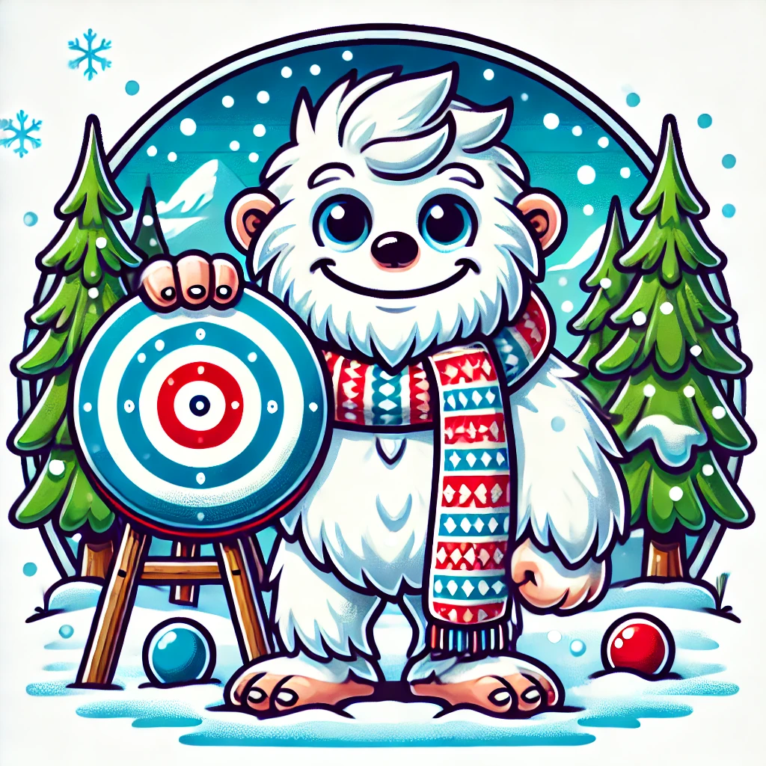

**YETI MONSTER TARGET**

Toss your snowball and try to hit the picture of the Yeti and the target.

