**Build-A-Snowman Riddle**

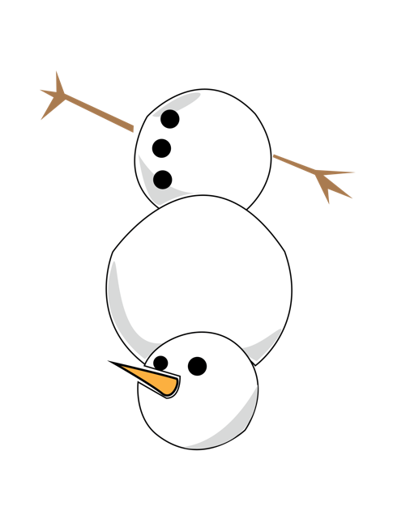Jack the Snowman is made up of  
3 snowballs stacked in a specific order:

* The bottom is the largest.
* The middle is medium-sized.
* The top is the smallest.

But Jack’s snowballs got mixed up!

**Can you figure out which order the snowballs  
should be in (from bottom to top) to make  
him look like a proper snowman?**

**Build-A-Snowman Riddle**

Can you figure out which order the snowballs  
should be in from top to bottom to make  
Jack look like a proper snowman?

**Answer:** Large, medium, small.

**Snowman Hat Swap**

Three snowmen (Sam, Sally, and Sid)  
each wear a different hat:

* + - Sam has a top hat,
    - Sally has a beanie,
    - Sid has a red bucket.

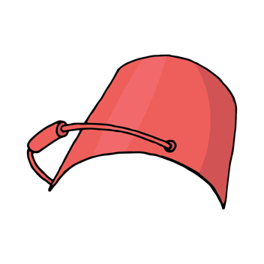

One windy day, their hats blew away and got mixed up.

* The top hat cannot fit on Sally’s   
  head because it’s too big.
* Sid’s bucket was found on Sam’s head.

**Who is wearing the top hat now?**

**Snowman Hat Swap**

One windy day, their hats blew away and got mixed up.

* The top hat cannot fit on Sally’s   
  head because it’s too big.
* Sid’s earmuffs were found on Sam’s head.

**Who is wearing the top hat now?**

**Answer:**Sid is wearing

the top hat.

**Snowball Math**

Sam is making a snow fort with 15 snowballs.

He uses 7 snowballs to build the walls

and 5 snowballs for decorations.

**How many snowballs does Sam have left?**

**Snowball Math**

Sam is making a snow fort with 15 snowballs.

He uses 7 snowballs to build the walls

and 5 snowballs for decorations.



**How many snowballs does Sam have left?**

**Answer:**

15 – 7 – 5 = 3

**Snowman Family Sweater Mystery**

The Snowman family left their sweaters in the snow:

* + - Dad’s sweater is **blue**.
    - Mom’s sweater is **red**.
    - Baby’s sweater is **green.**

All of the sweaters are lined up.

**Whose sweater is in the middle?**

*Clues:*

* + - The blue sweater is not next to the red sweater.
    - The red sweater is to the left of the green sweater.

**Snowman Family Sweater Mystery**

The Snowman family left their sweaters in the snow:

Dad’s sweater is **blue**. Mom’s sweater is **red**.

Baby’s sweater is **green.**

**Whose sweater is in the middle?**

**Answer:** Baby’s (**green** sweater)

**Snowman Race Day**

Four snowmen are having a race.

* + - * 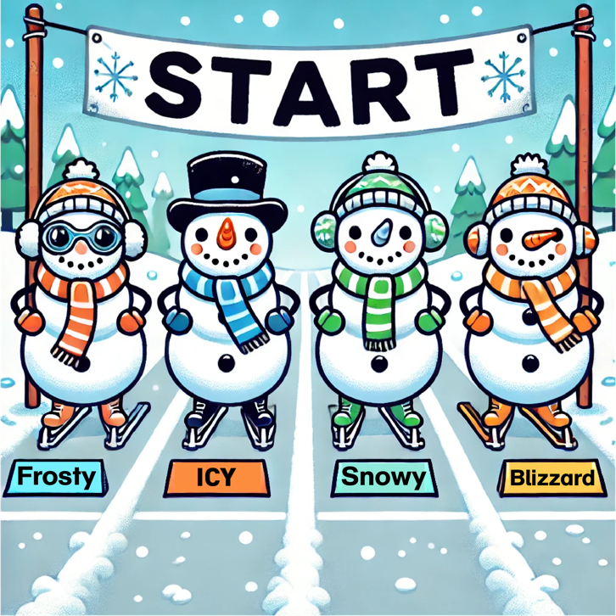Frosty is faster than Snowy.
      * Icy is faster than Blizzard.
      * Snowy is faster than Blizzard.
      * Frosty is not the fastest.

**Who wins the race?**

**Snowman Race Day**

Four snowmen are having a race.

* + - * 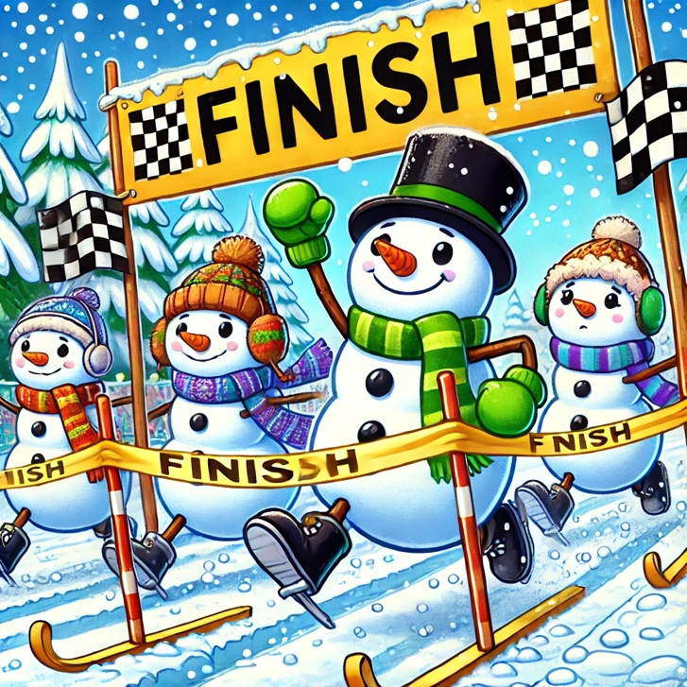Frosty is faster than Snowy.
      * Icy is faster than Blizzard.
      * Snowy is faster than Blizzard.
      * Frosty is not the fastest.

**Who wins the race?**

**Answer:** Icy Wins!