SNOWMAN ARTWORK Created by: Kendra
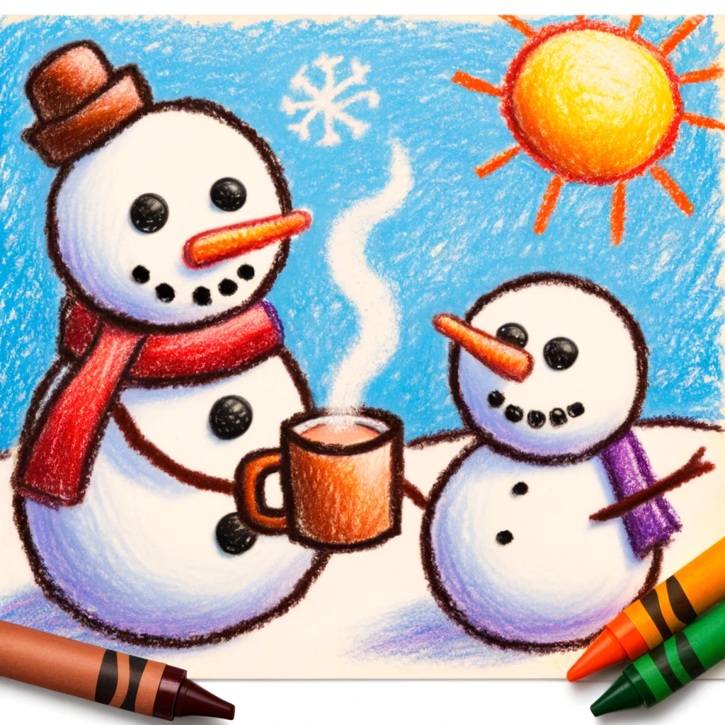

My inspirational word is: Generosity

